Project Description

Name of Assignment/Project
Advocacy with national level stakeholders to strengthen implementation of TAPS ban in Bangladesh through institutional directives and strategic litigations
Project Location :  Overall Bangladesh | Approx. Value of the Contract :  BDT 4671064  USD 60389
Name of Donor & Address :  Campaign for Tobacco Free Kids &  Bloomberg Philanthropies  1400 Street NW, Suite 1200  Washington, DC 20005, USA | Duration of assignment (months): 12  April1,2015-March31, 2016
Beneficiaries :  Entire population of Bangladesh (150 million) will be affected by the project | Name of venture partner :  N/A
Goal:
The major purpose of the project is to influence the key players for generating necessary decisions/circulars/orders from relevant bodies to ensure more effective implementation of TAPS ban in light of the Bangladesh law using policy advocacy and litigation as tools.

Objectives:
1. To conduct advocacy and lobbying with Ministry of Information (MoI), other relevant ministries and national associations for issuance of institutional directives/circulars/orders required for effective implementation of TAPS ban
2. To generate evidences and develop detailed plans for at least two strategic litigations for supporting implementation of TAPS ban
3. To share the model developed by EC Bangladesh of using community radio for implementation of tobacco control law and motivate the radio authorities for implementing the model in their respective jurisdictions
Narrative Description of Project:
This project aims to contribute to the tobacco control movement of Bangladesh by advocating for comprehensive tobacco advertising and promotion ban within the amendment of the 2005 tobacco control law. The progress of execution of TAPS ban is very slow in Bangladesh due to overall lack of implementation of the tobacco control law that was amended in 2013 to make TAPS ban comprehensive and more compliant to FCTC.
The proposed project focuses on implementing TAPS ban through advocacy and lobbying with national level stakeholders, Public Interest Litigation against TAPS violation and using community radios to create awareness among relevant stakeholder in implementing tobacco control law. The proposed project activities will be directed to influence national level officials and association members in issuance of directives on TAPS ban in their respective jurisdictions. Simultaneously, the project team will work on documenting all types of TAPS violation and developing detailed plan for strategic litigation purpose. The project will also be involved in engaging community radios across the country through sharing a community radio model developed and successfully piloted by EC Bangladesh for supporting implementation of tobacco control law.
Initially the project period is one year.
Description of actual services provided in the assignment:
The major services included are as follows:
Issuance of central level directives
Within this project one of the key working area is to influence the key players for generating necessary decisions/circulars/orders from relevant bodies to ensure more effective implementation of TAPS ban in light of the Bangladesh law. In order to prevent all sorts of violation central level directives and ensuring abidance of law is necessary.
Advocacy and capacity building
Within this project advocacy and capacity building strategies will applied to create consensus among relevant associations and make them involved in TAPS ban implementation in their respective areas.
Documentation on tobacco advertising, promotion and sponsorship:
An investigation will conduct on documentation of ongoing tobacco advertising, promotion and sponsorship. The report will project ongoing tricky advertising and promotional activity in POS, media and in the name of CSR. The purpose of this study is to capture the entire scenario of TAPS ban violation in Bangladesh which will be helpful for tobacco control law implementation. The report will published and circulated to relevant stakeholders.
Compliance survey and developing communication materials for policy makers and for other stakeholder
In order to project TAPS scenario and law abidance one round compliance survey will done which will be helpful for generating evidence of law violation. Within this project various communication materials like brochure, factsheet containing anti-tobacco messages and TAPS scenario will be prepared for policy makers and other stakeholders. These will be distributed to BI grantees, tobacco-control NGOs, international and government agencies for the purpose of sensitization on tobacco control. Disseminating Community Radio Tobacco Control Model
Previously EC Bangladesh developed Tobacco Control Model by involving community radio and successfully piloted it through Radio Bikrampur 99.2 FM. The developed model can be used for assisting other community radios for reinforcing their roles in effective implementation of tobacco control law. EC Bangladesh will organize a workshop and share the model of how community radio can be an effective medium for reducing tobacco control law violation. On the other hand EC Bangladesh want to replicate this model through other community radio’s and will give award that will be pioneered in replicating this model or best practiced community radio for the contribution in effective implementation of law.
Networking:
For sensitizing on tobacco control issue specially on tobacco advertising, promotion and sponsorship networking with various organizations, volunteer groups, media and govt. officials will establish.
Sensitization and mobilization
Within this project different mobilization campaign by engaging youth and community people will be done. Sensitization and mobilize of youth is needed as they are the most affected and vulnerable population to TAPS and it will be effective if they speak out for the need of a comprehensive TAPS ban.

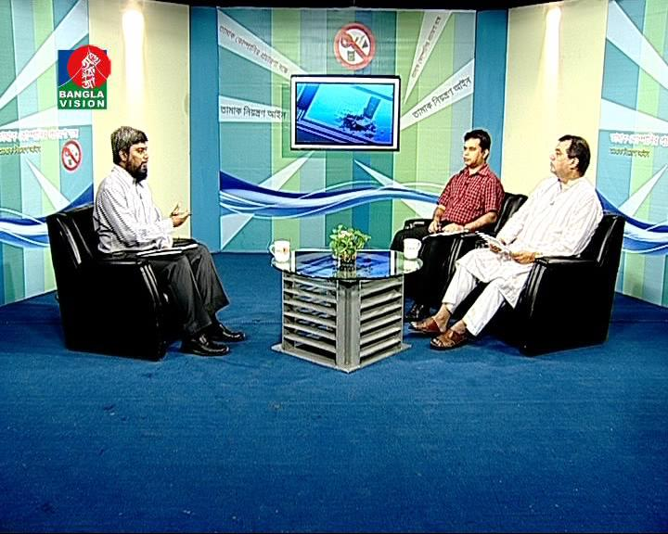 |  | 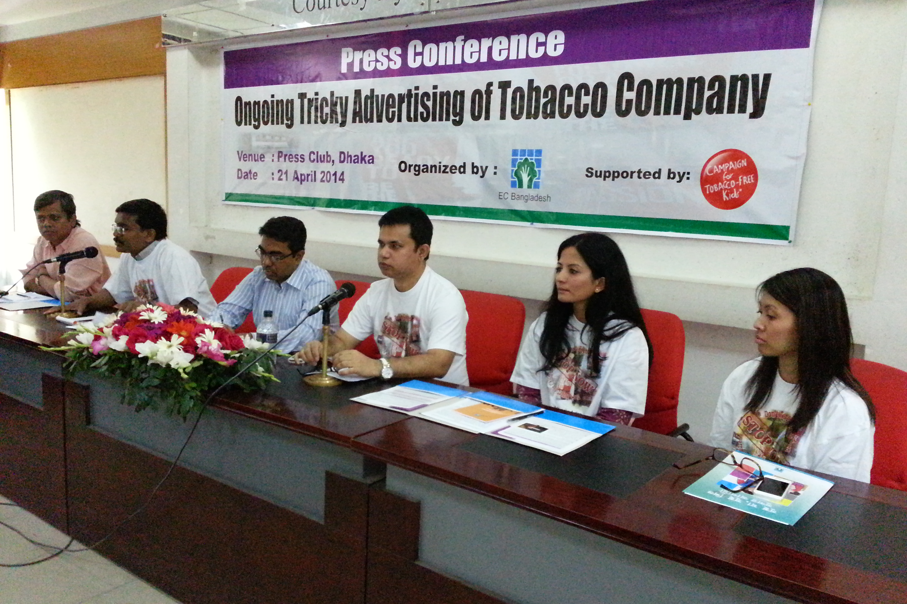
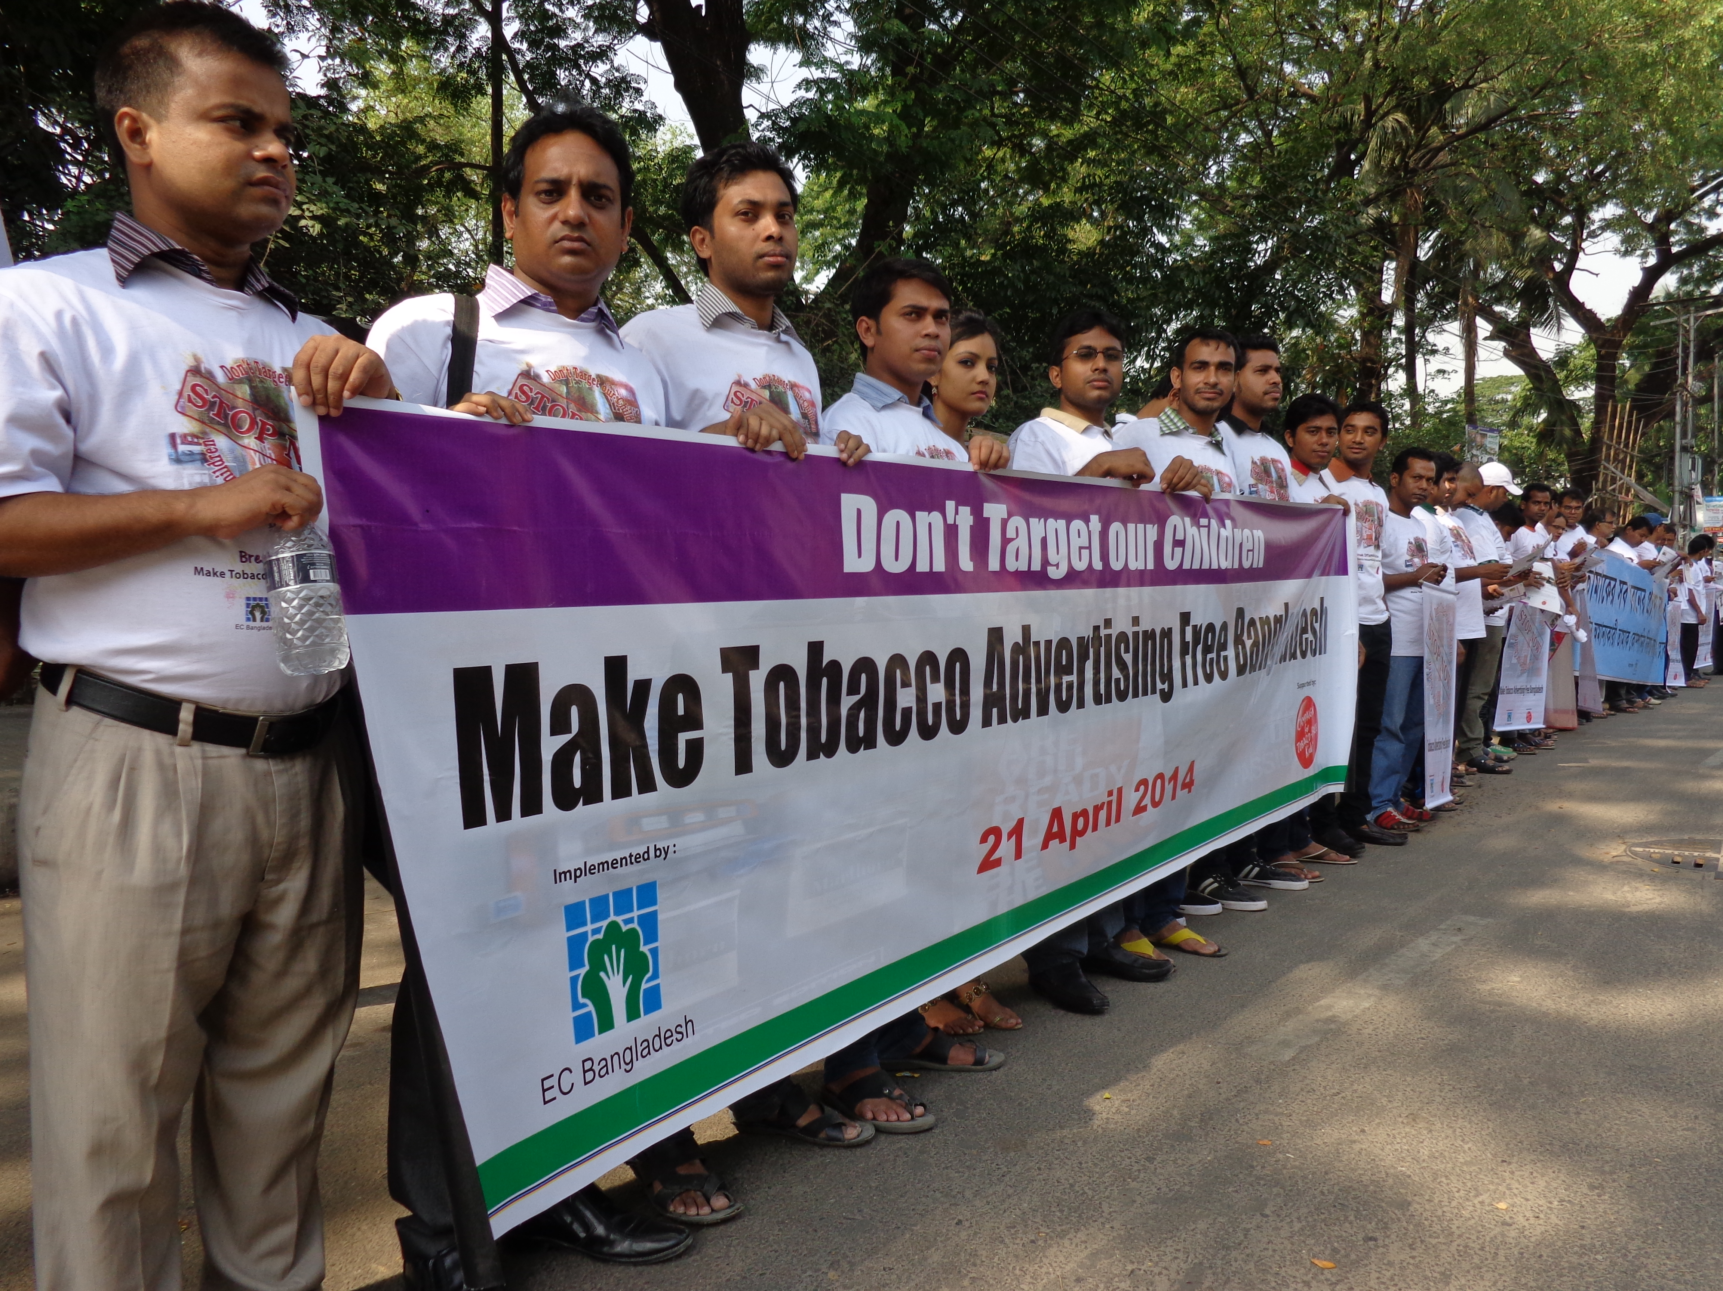 |  | 

