Project Description

Name of Assignment/Project
Classroom Library for Government and Registered Primary School
Project Location :  Brahmmanbaria Sdar and BijoyNagar upazila of Brahmmanbaria | Approx. Value of the Contract :  BDT 45,540,150.65  US$ 569,251.88
Name of Donor & Address :  Room to Read  6/3 Lalmatia , Block D, Dhaka,  Bangladesh  Phone:+880 2-9122737 | Duration of assignment (months): 76  September 2009 to December 2015
Beneficiaries :  Direct: About 10000 students  Indirect : More than 56000 people | Name of venture partner :  N/A
Goal:
Promote literacy and the habit of reading in children.
Objectives:
- To increase children’s reading and writing skills on the language of instruction in primary and secondary school
- To increase children’s reading and writing skills on the second language taught in primary and secondary school
- To increase availability of Reading Materials to children
- To increase children’s usage of Reading Materials
- To increase teachers’ motivation and capacity on managing and using the library resources
- To build awareness of parents, school management committee and other community members on the importance of literacy and reading
- To enrich learning environment of schools
Narrative Description of Project:
The project works to establish the Classroom Library for government and registered primary school. The project aims to involve the Children of the identified 125 schools in Brahmanbaria district to increase their literacy skills, reading habit, and provided with increased reading opportunities by enriching learning processes and environment. All the students of selected schools are target beneficiaries. Children coverage by the year 2009 was 6250, additional 1250 were covered in each year and by the end of 2015 the more than 10000 target children will be involved.
Description of actual services provided in the assignment:
The major services included are as follows:

Establishment of Classroom Library and education materials distribution:
In order to improve the reading habit of the children, this project has established total xxx classroom library in each target primary and registered schools. Necessary books, furniture and some other reading materials were distributed to the school libraries under this project.
Construction and repairing activities:
According to the need assessment of the concerned school, necessary action was taken for constructing and repairing the reading rooms. Activities like painting blackboard and classroom wall etc was done after construction and repairing activities.
Training for the teachers
For managing and running the classroom libraries concerned teachers were provided with training by the implementing the project. On an average five teachers from each school were selected for receiving the training. During training period representatives from ‘ROOM TO READ’ and upazila education officer were invited to attend the training session.
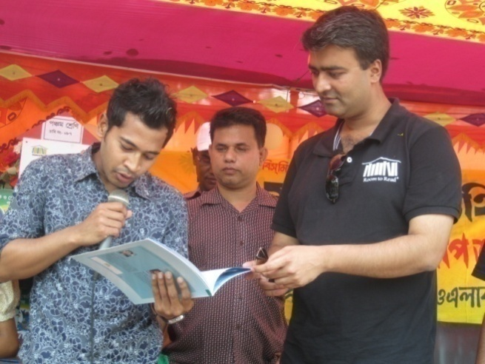 |  | 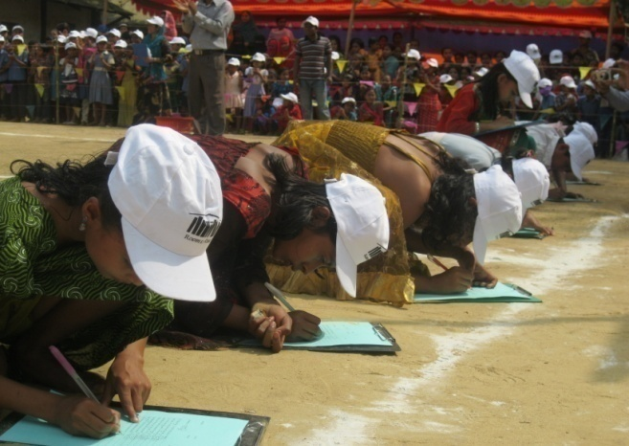
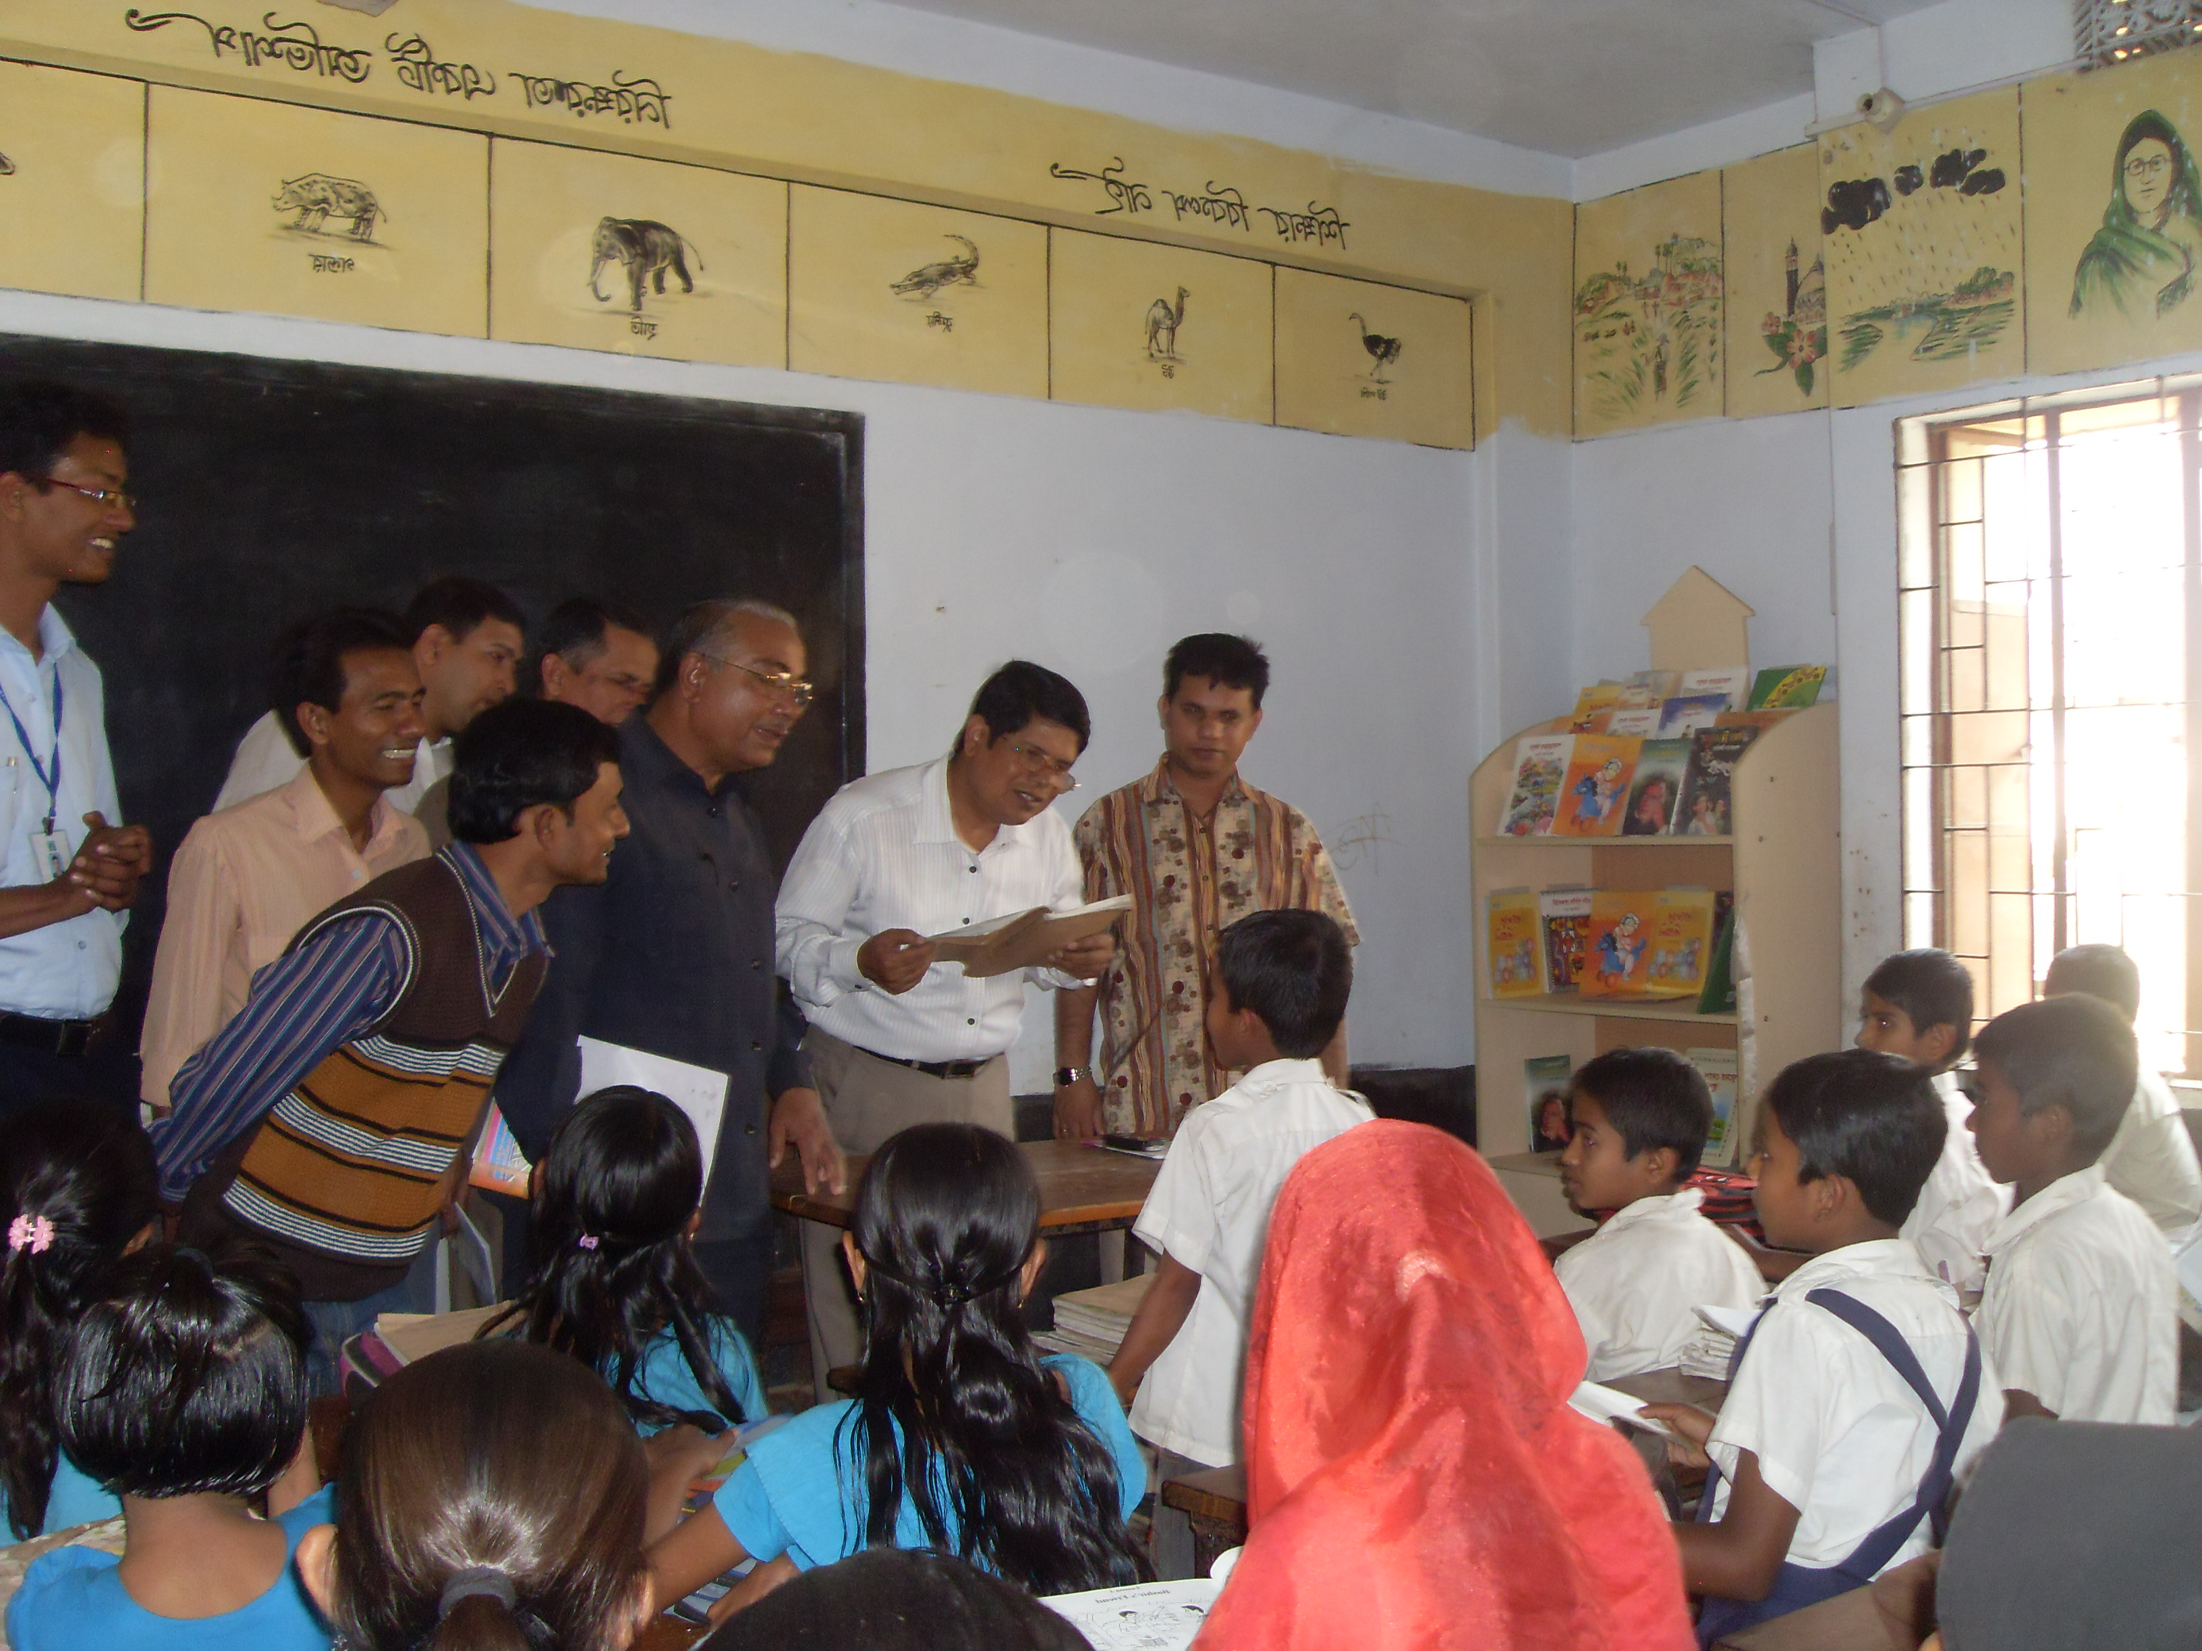 |  | 

