Project Description

Title | : | Community Based Nutrition Component Under BINP, Phase 4
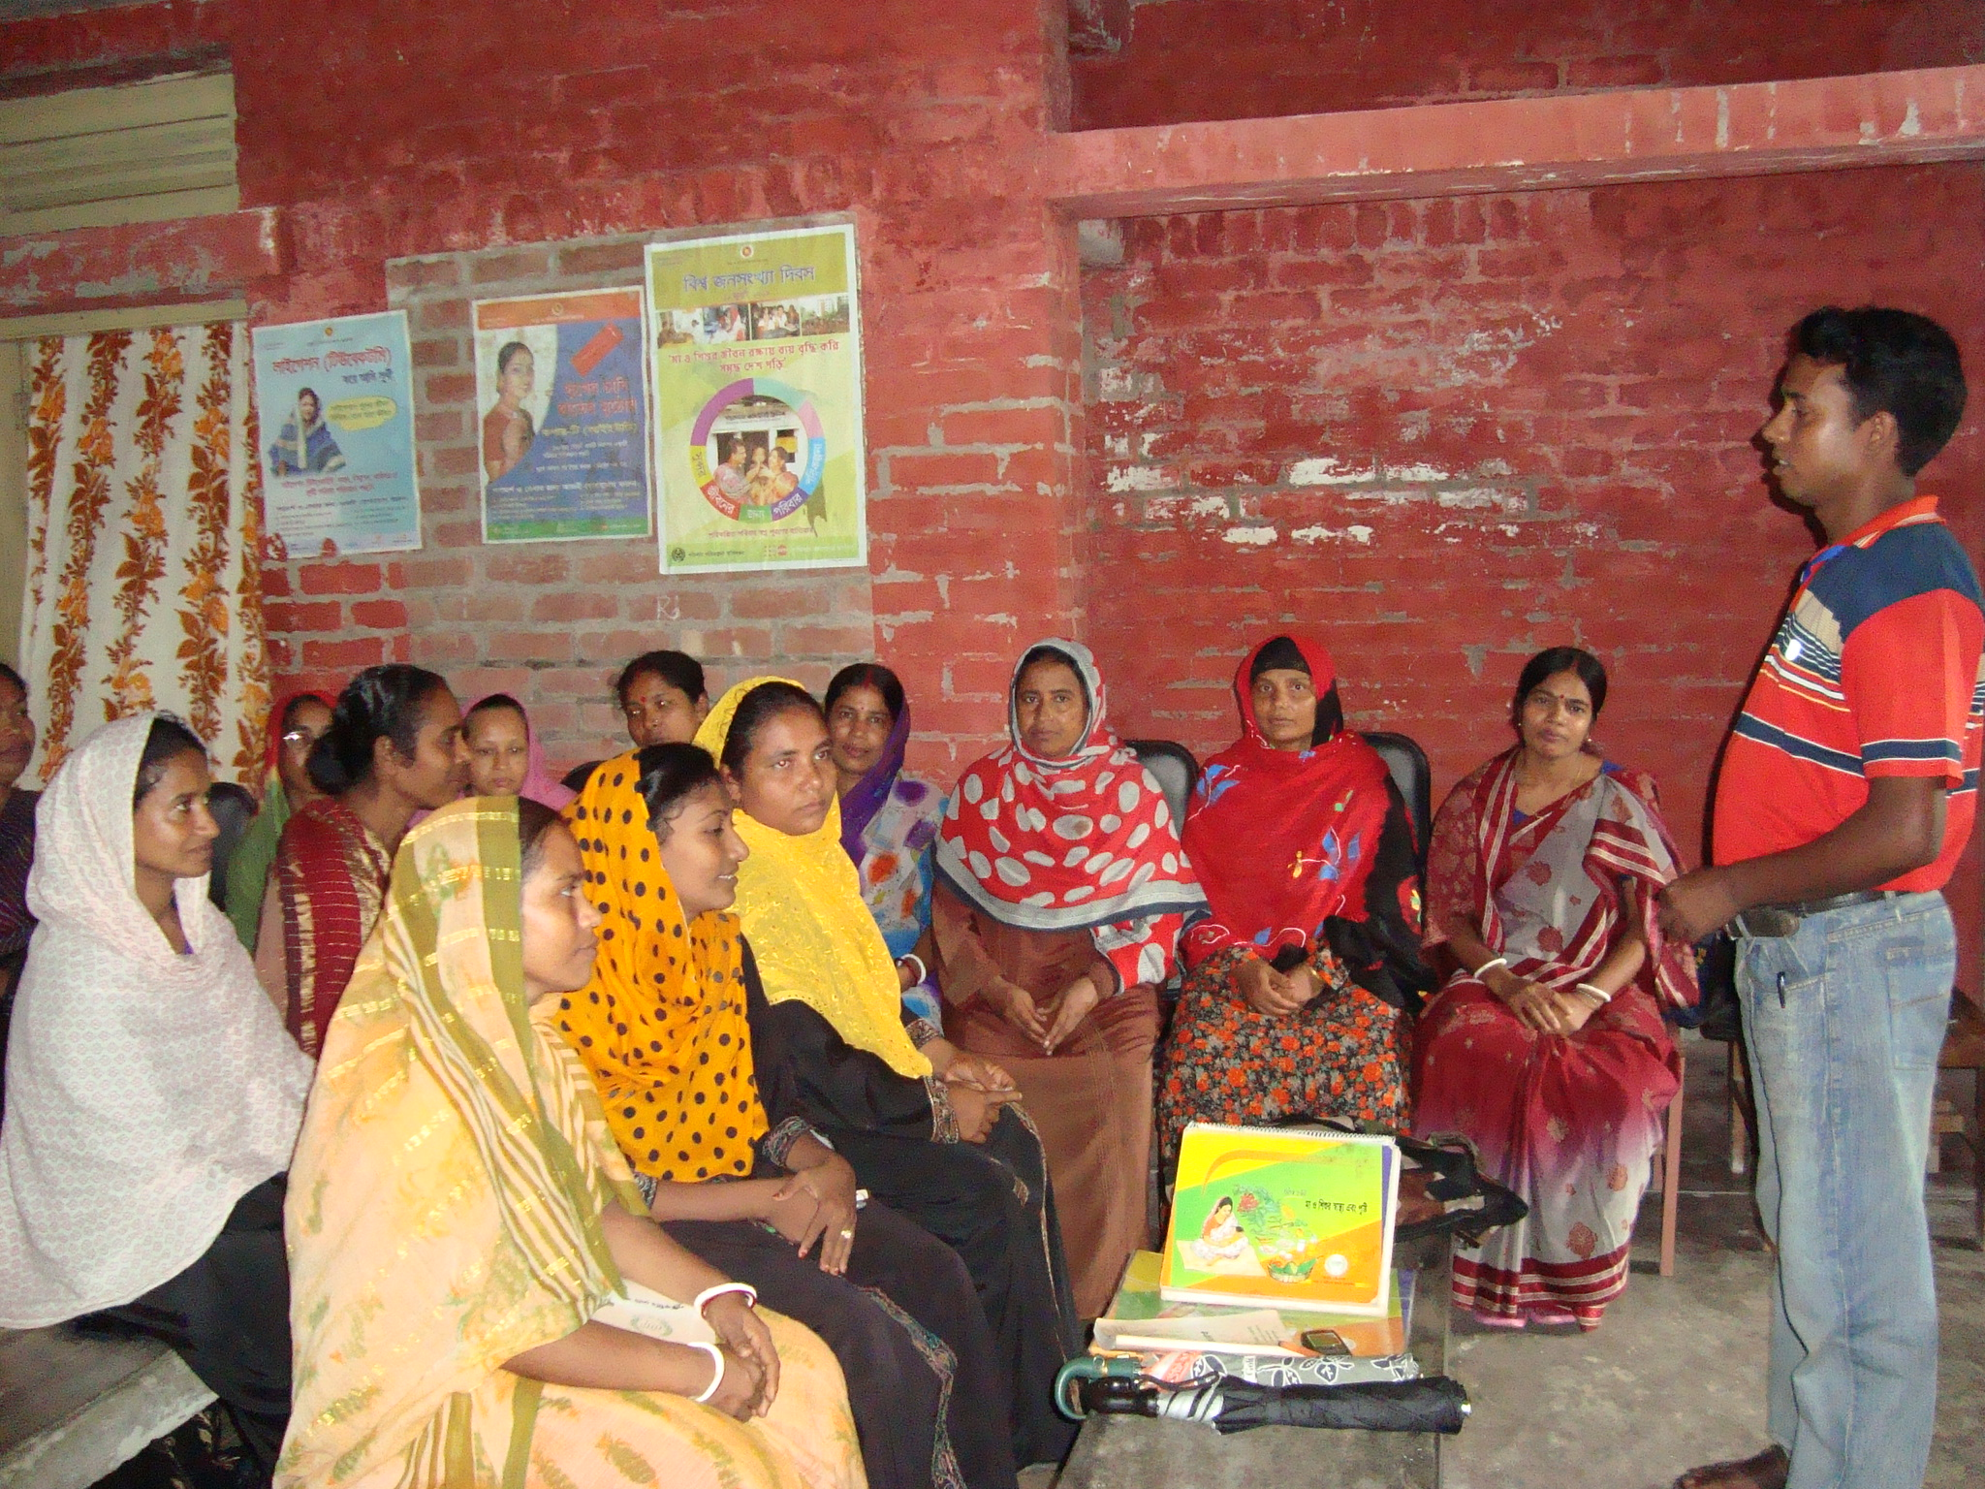 |  |  | 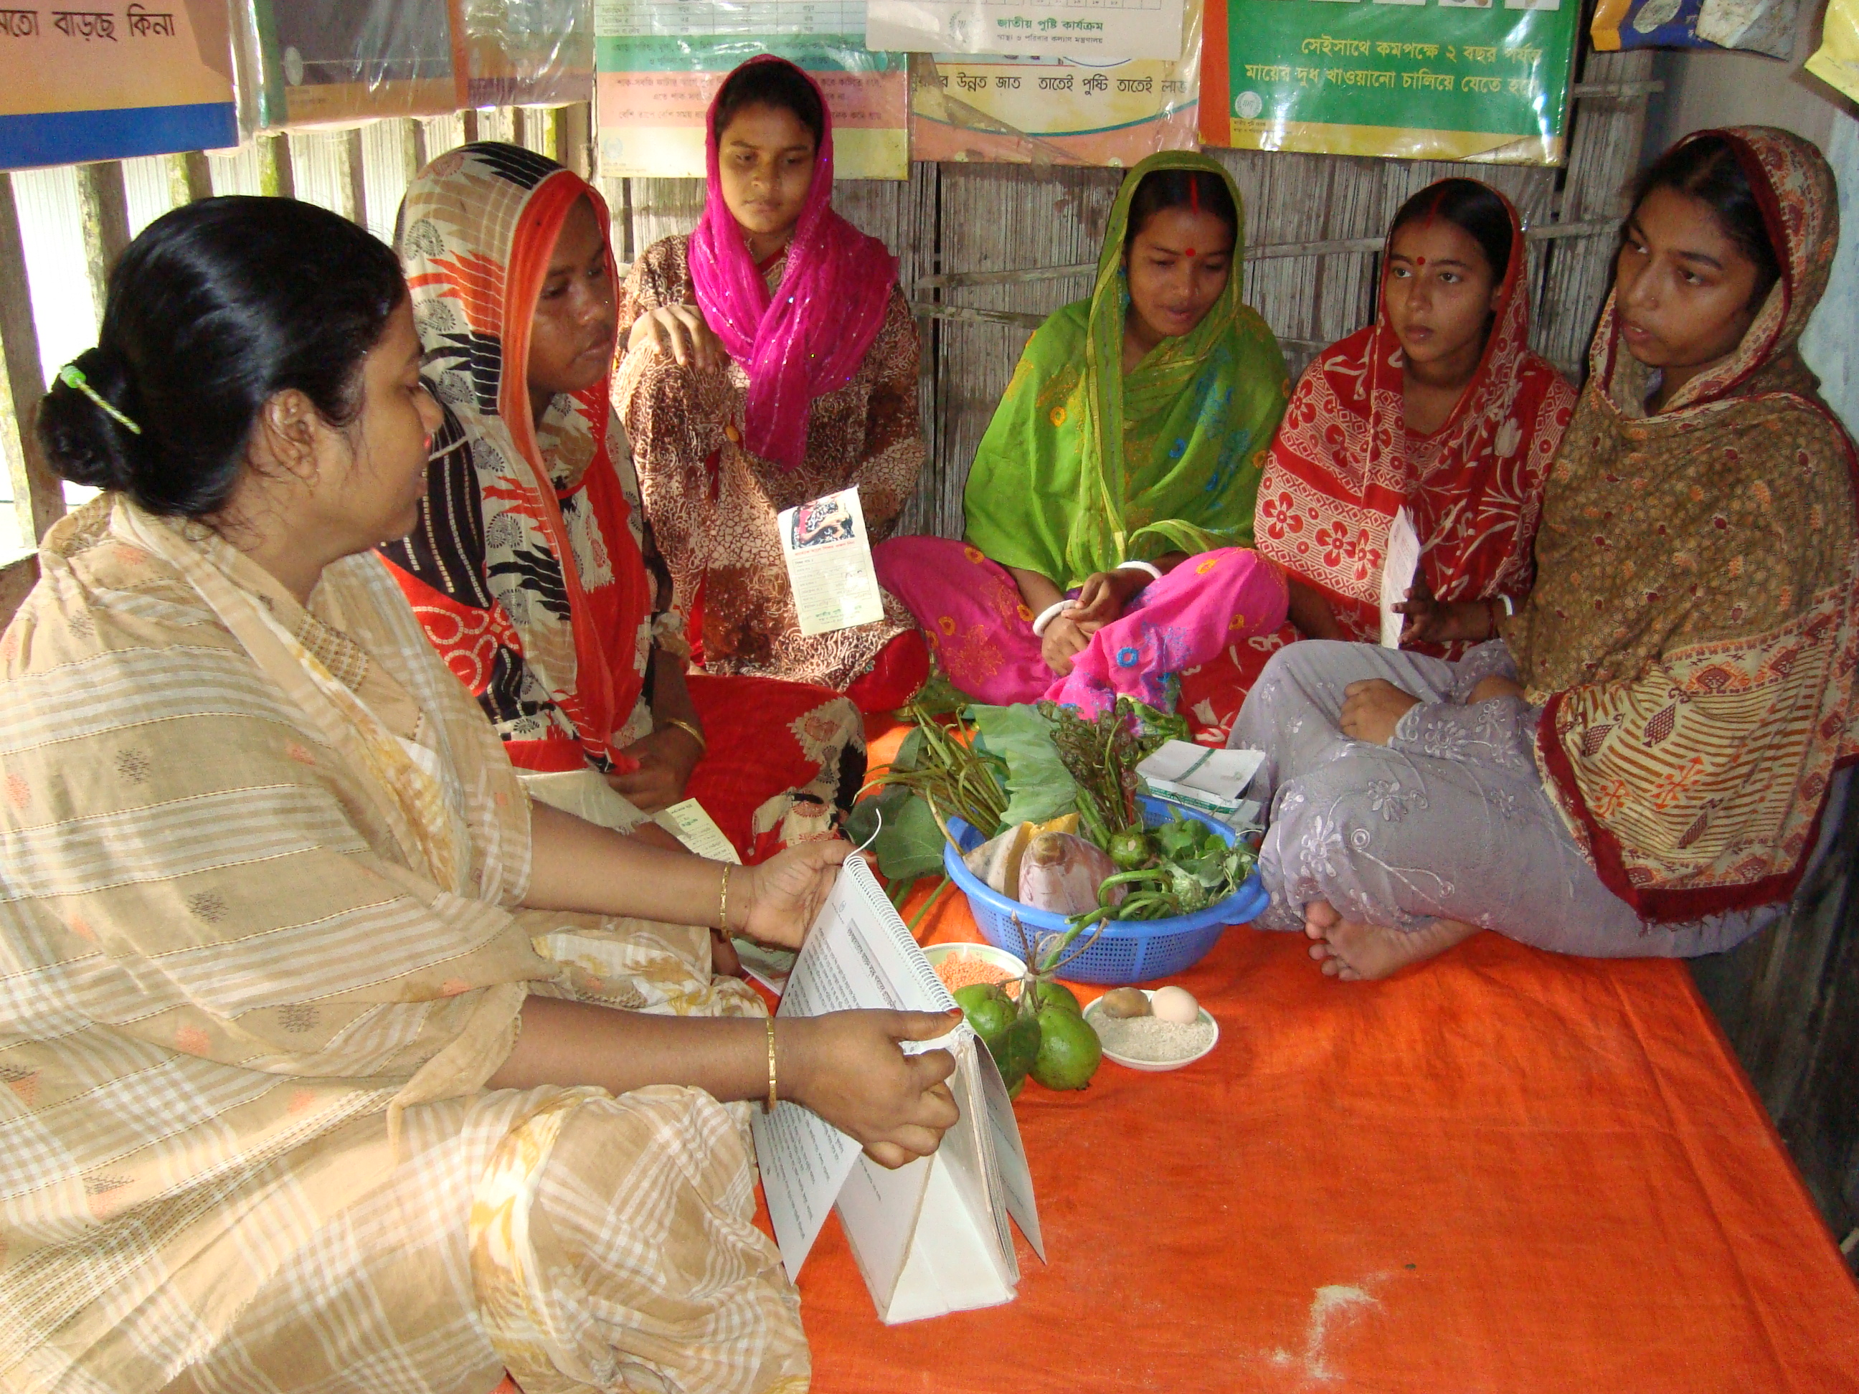
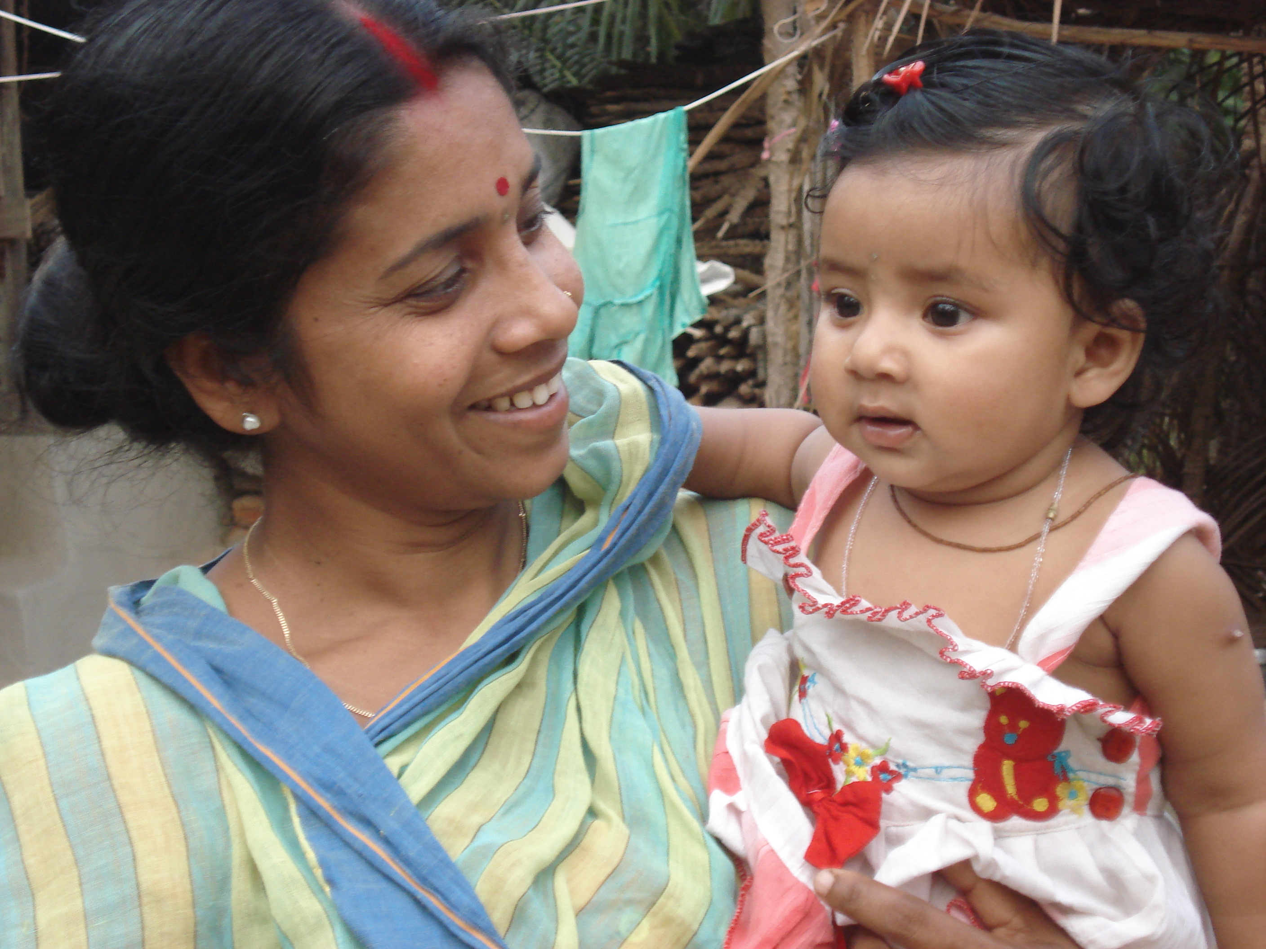 |  |  | 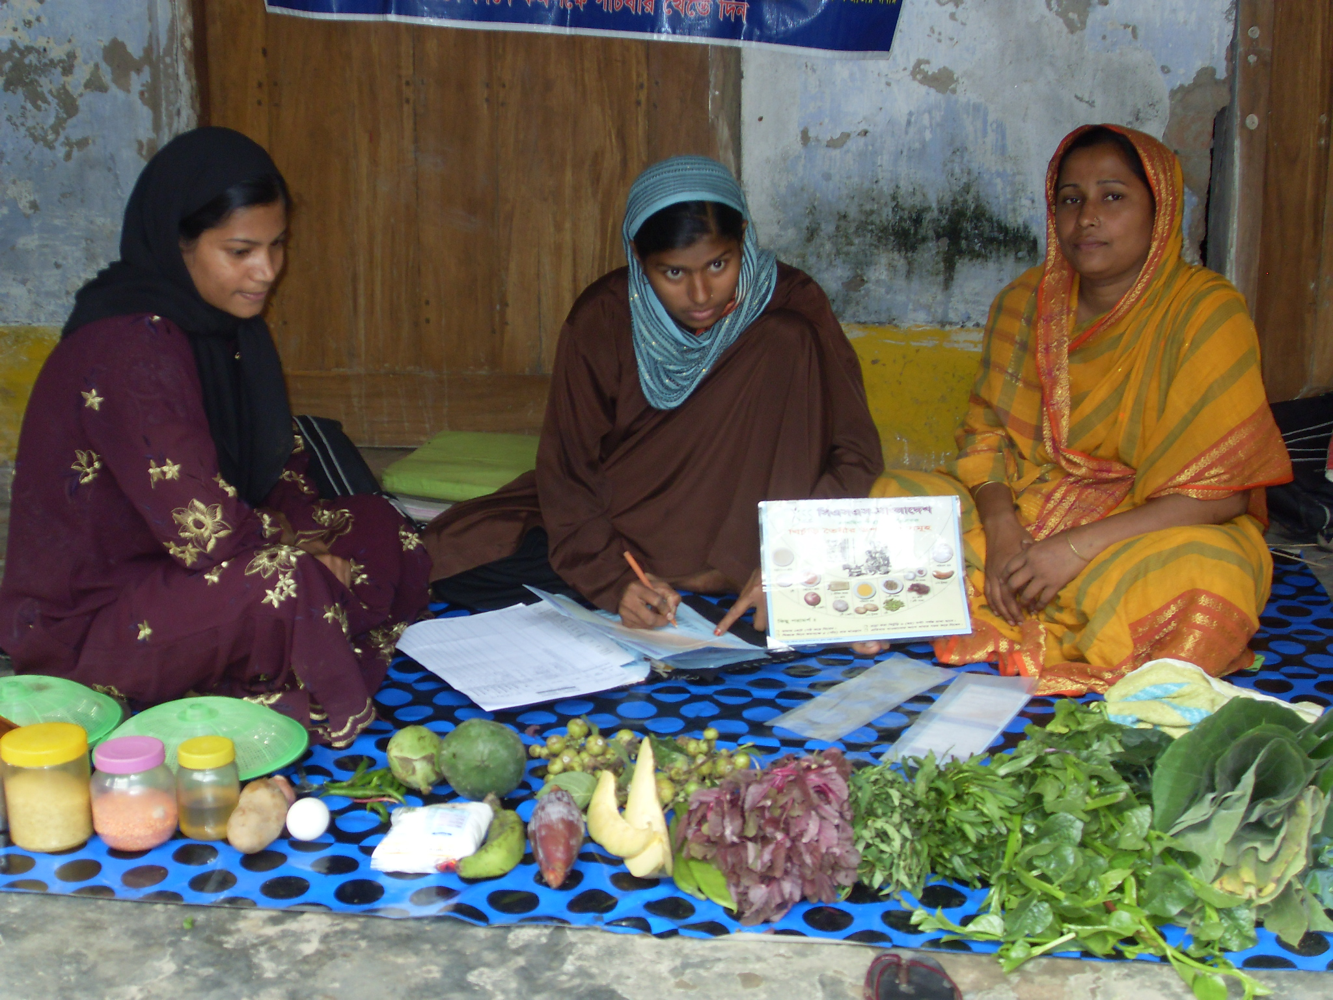
Project Location:  Monohordi upazila, Narsingdi District |  |  | Approx. Value of the Contract :  BDT 49,0,000.00  USD 6305.8
Name of Donor & Address:  Mo/H&FW, World Bank |  |  | Duration of assignment (months):  3 months (January 2002 to March 2002)
Beneficiaries :  Children: 4073, Mother: 4799,  Adolescent: 14764, new marriage couple: 328 |  |  | Name of venture partner:  N/A
Goal:
Promote sustainable improvement in birth weight and in the nutrition status of community people through adoption of new behaviours and nutrition services

Objectives:
- To reduce the prevalence of Low Birth Weight and prevalence of underweight in children
- To increase pregnancy weight gain of pregnant women.
- To promote positive attitudes and behavioral changes that result in improved adequate nutritional intakes and better dietary utilization
Narrative Description of Project:
Under this project we have identified the pregnant mother as well as <2 years baby according to Government Satellite Clinic report and birth weight status of the baby. The Ante Natal Mothers and <2 years babies those who are malnourished, we provided them Weaning supplementary food for promoting their health status from third to first degree. Despite of this, the following activities is being implemented for the selected areas community’s for the promotion of nutritional status, these are as follows:
  - Social Mobilization and Advocacy;
  - Growth Monitoring and Promotion
  - BCC Reach
  - Supply of Supplementary Food;
  - Refreshers Training;
  - Monitor Ante and Post Natal Care;
  - Monitor & to Prepare Weaning and Supplementary Food and its Practice by beneficiaries;
  - Household visit/conduct Education Session;
  - Supply of Sapling and Seedlings;
  - Monitor Personal Hygiene;
  - Ensure Expended Programme on Immunization (EPI);
  - Prevention of Water Borne and Faucal Borne Disease
Description of actual services provided in the assignment:

While implementing the projects and providing the health and nutrient services, EC Bangladesh has monitored independently the activities of different service providing institution’s services. In collaboration with local institutions the following services also have been included:
- Breast feeding promotion
- Micro-nutrient supplementation,
- Fortification of appropriate foods with micro-nutrients.
To provide the services relating to health and nutrition, following activities have been performed:

Advocacy Workshop:
To ensure better maternity services and baby friendly environment EC staff has conducted advocacy workshop with the participation of all remaining government and no-government hospitals authority.

Refresher Training:
EC staff has conducted refresher training for the field workers in every month. In the training they create an opportunity to share various experience gained from the working field with one another. They have presented successful story and different problems faced in the field. EC staff helped in identifying the solving process.
Counseling:
The trained workers provided counseling on issues such as reproductive health, nutrition and personal hygiene. Such program will call for Intensive Behavioral Change Communication activities.

Weight, height and BMI monitoring:
Each month, the responsible person measured each member’s weight and height and calculate a BMI, The purpose of this assessment is to focus attention on proper nutritional status, not to screen participants for feeding (no feeding to be provided for adolescent girls).

Micro-nutrient Supplementation:
Each member received a monthly supply of iron/foliate tablets (tablets of 60mg iron 250 µg foliate taken as two tablets once weekly). The concerned person would distribute the tablets, recording each member’ s receipt of the tablets along with the member’s reported number of tablets consumed in the last month. Every six months the CNP administered a single dose of albendazole (400mg) to each member and record the administration.

