Project Description

Title | : | Promoting and Protecting the Rights of Marginal Fisher
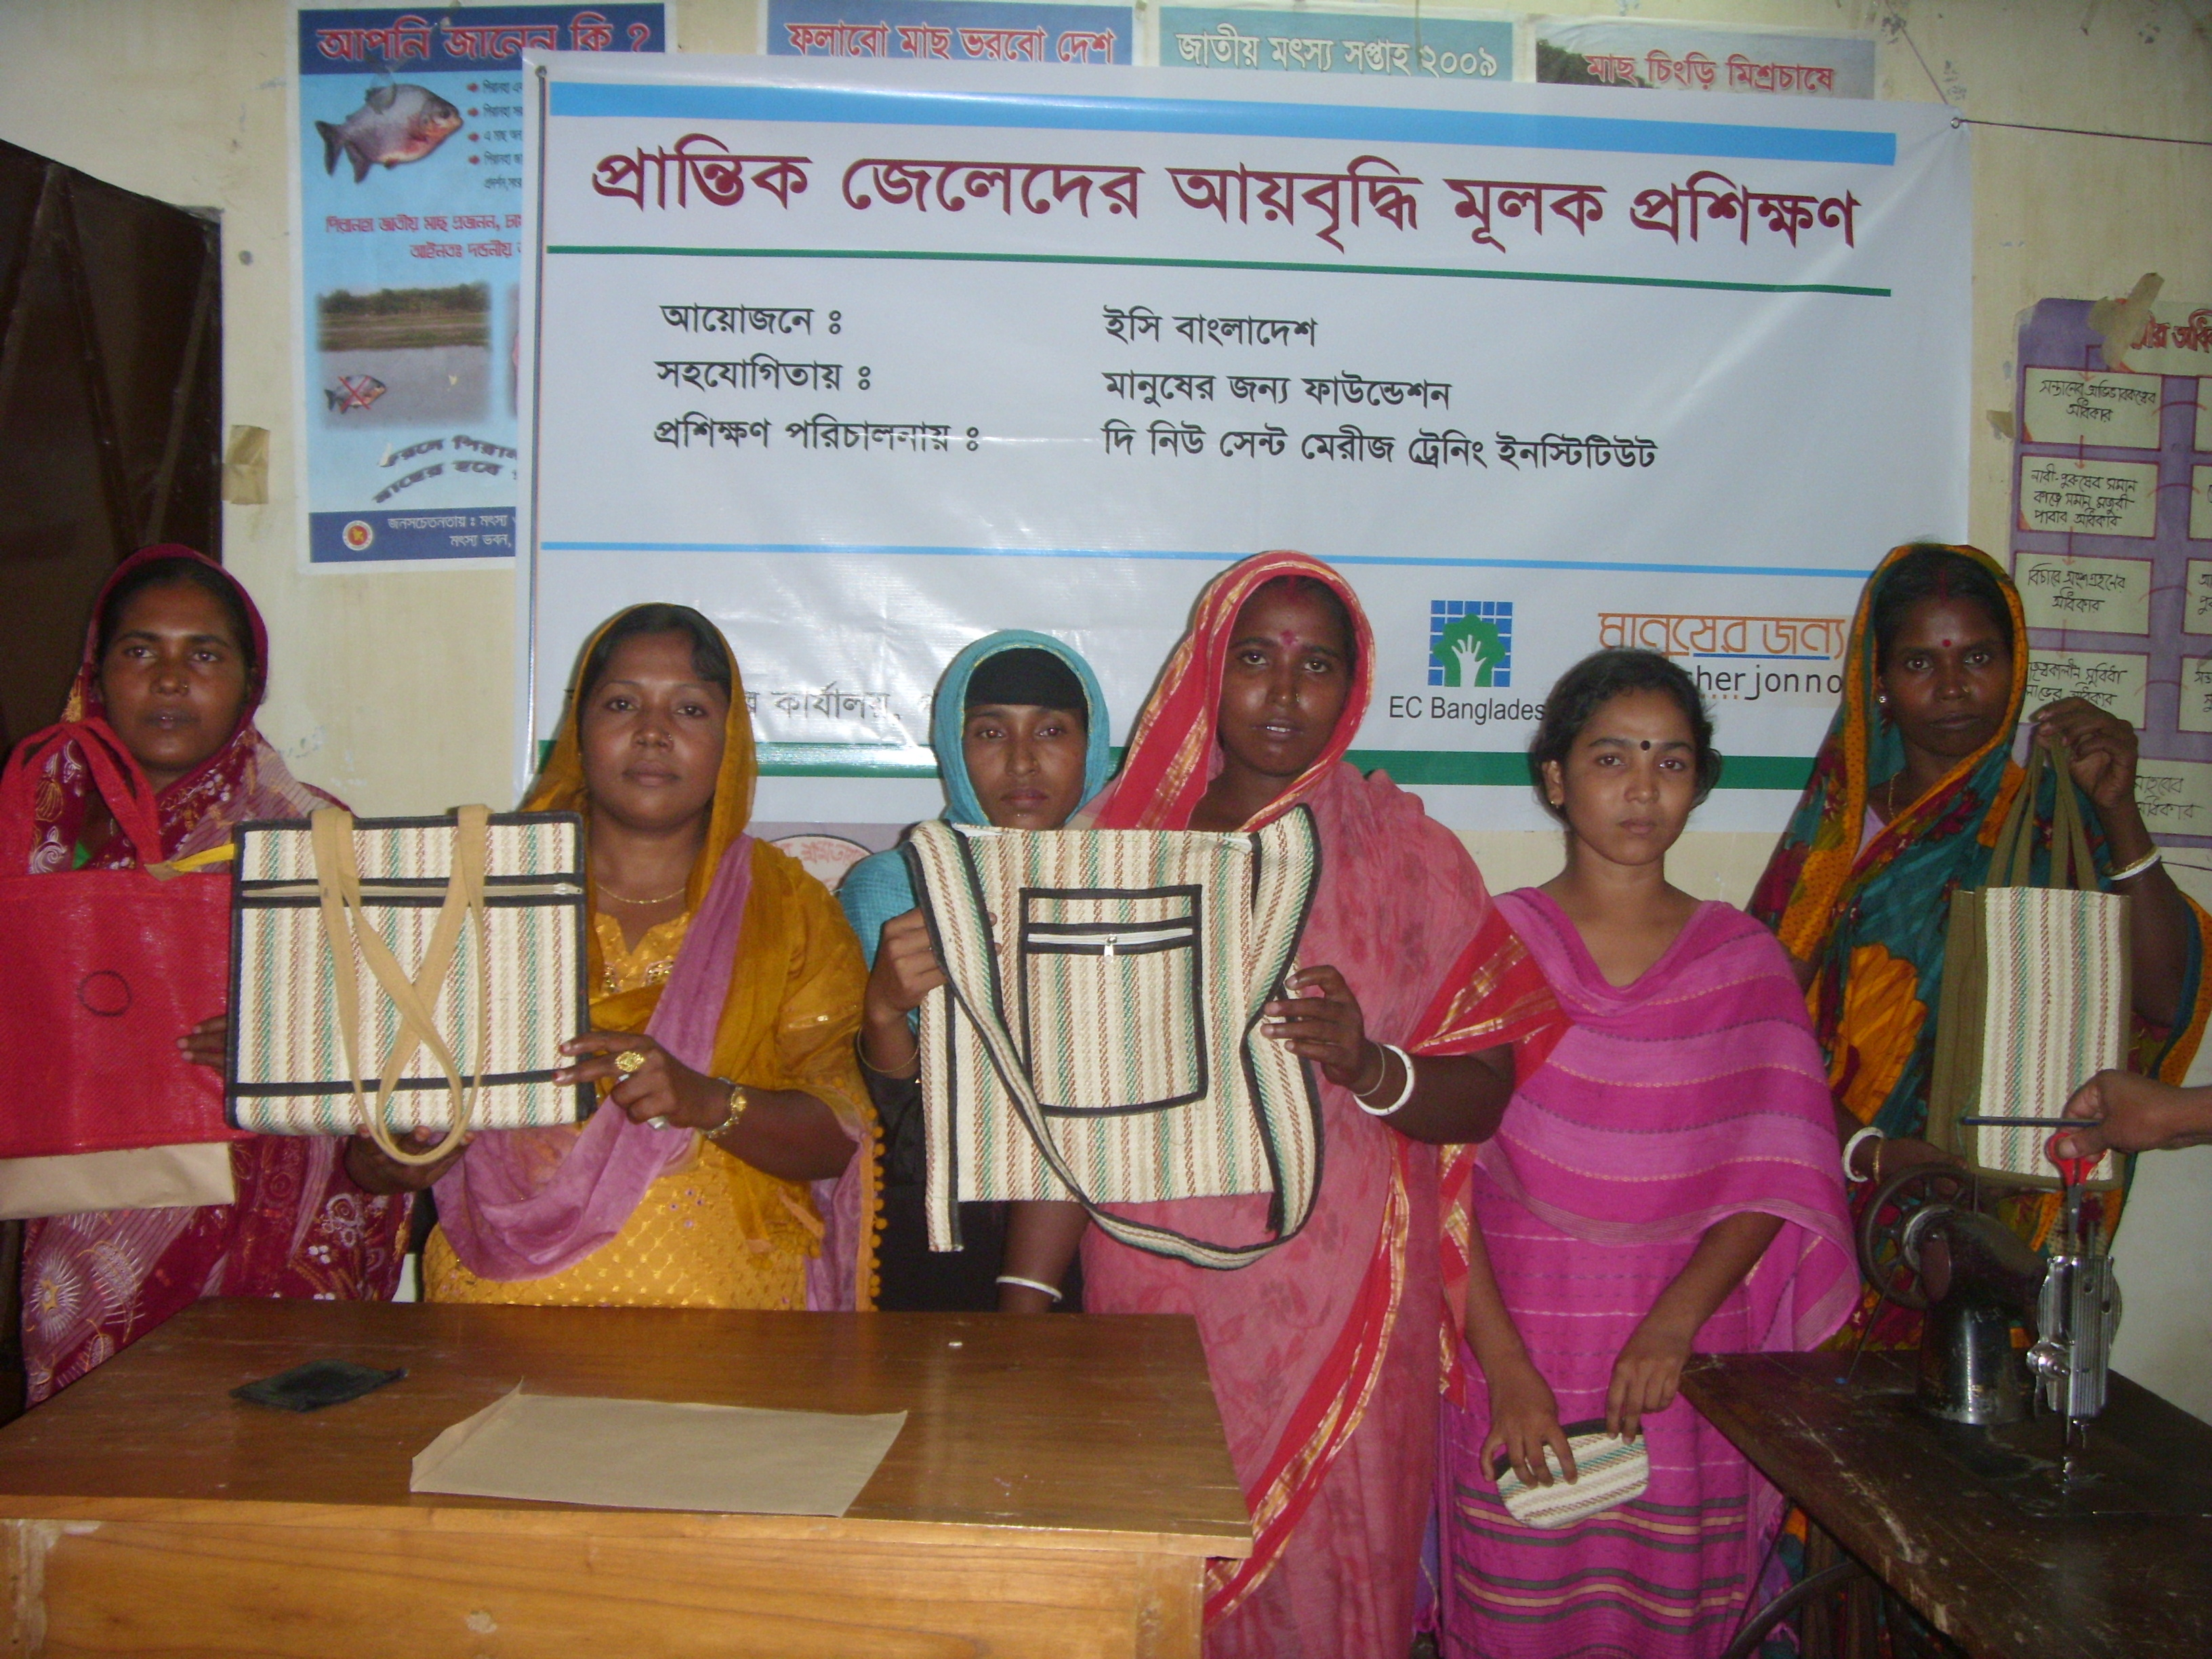 |  |  | 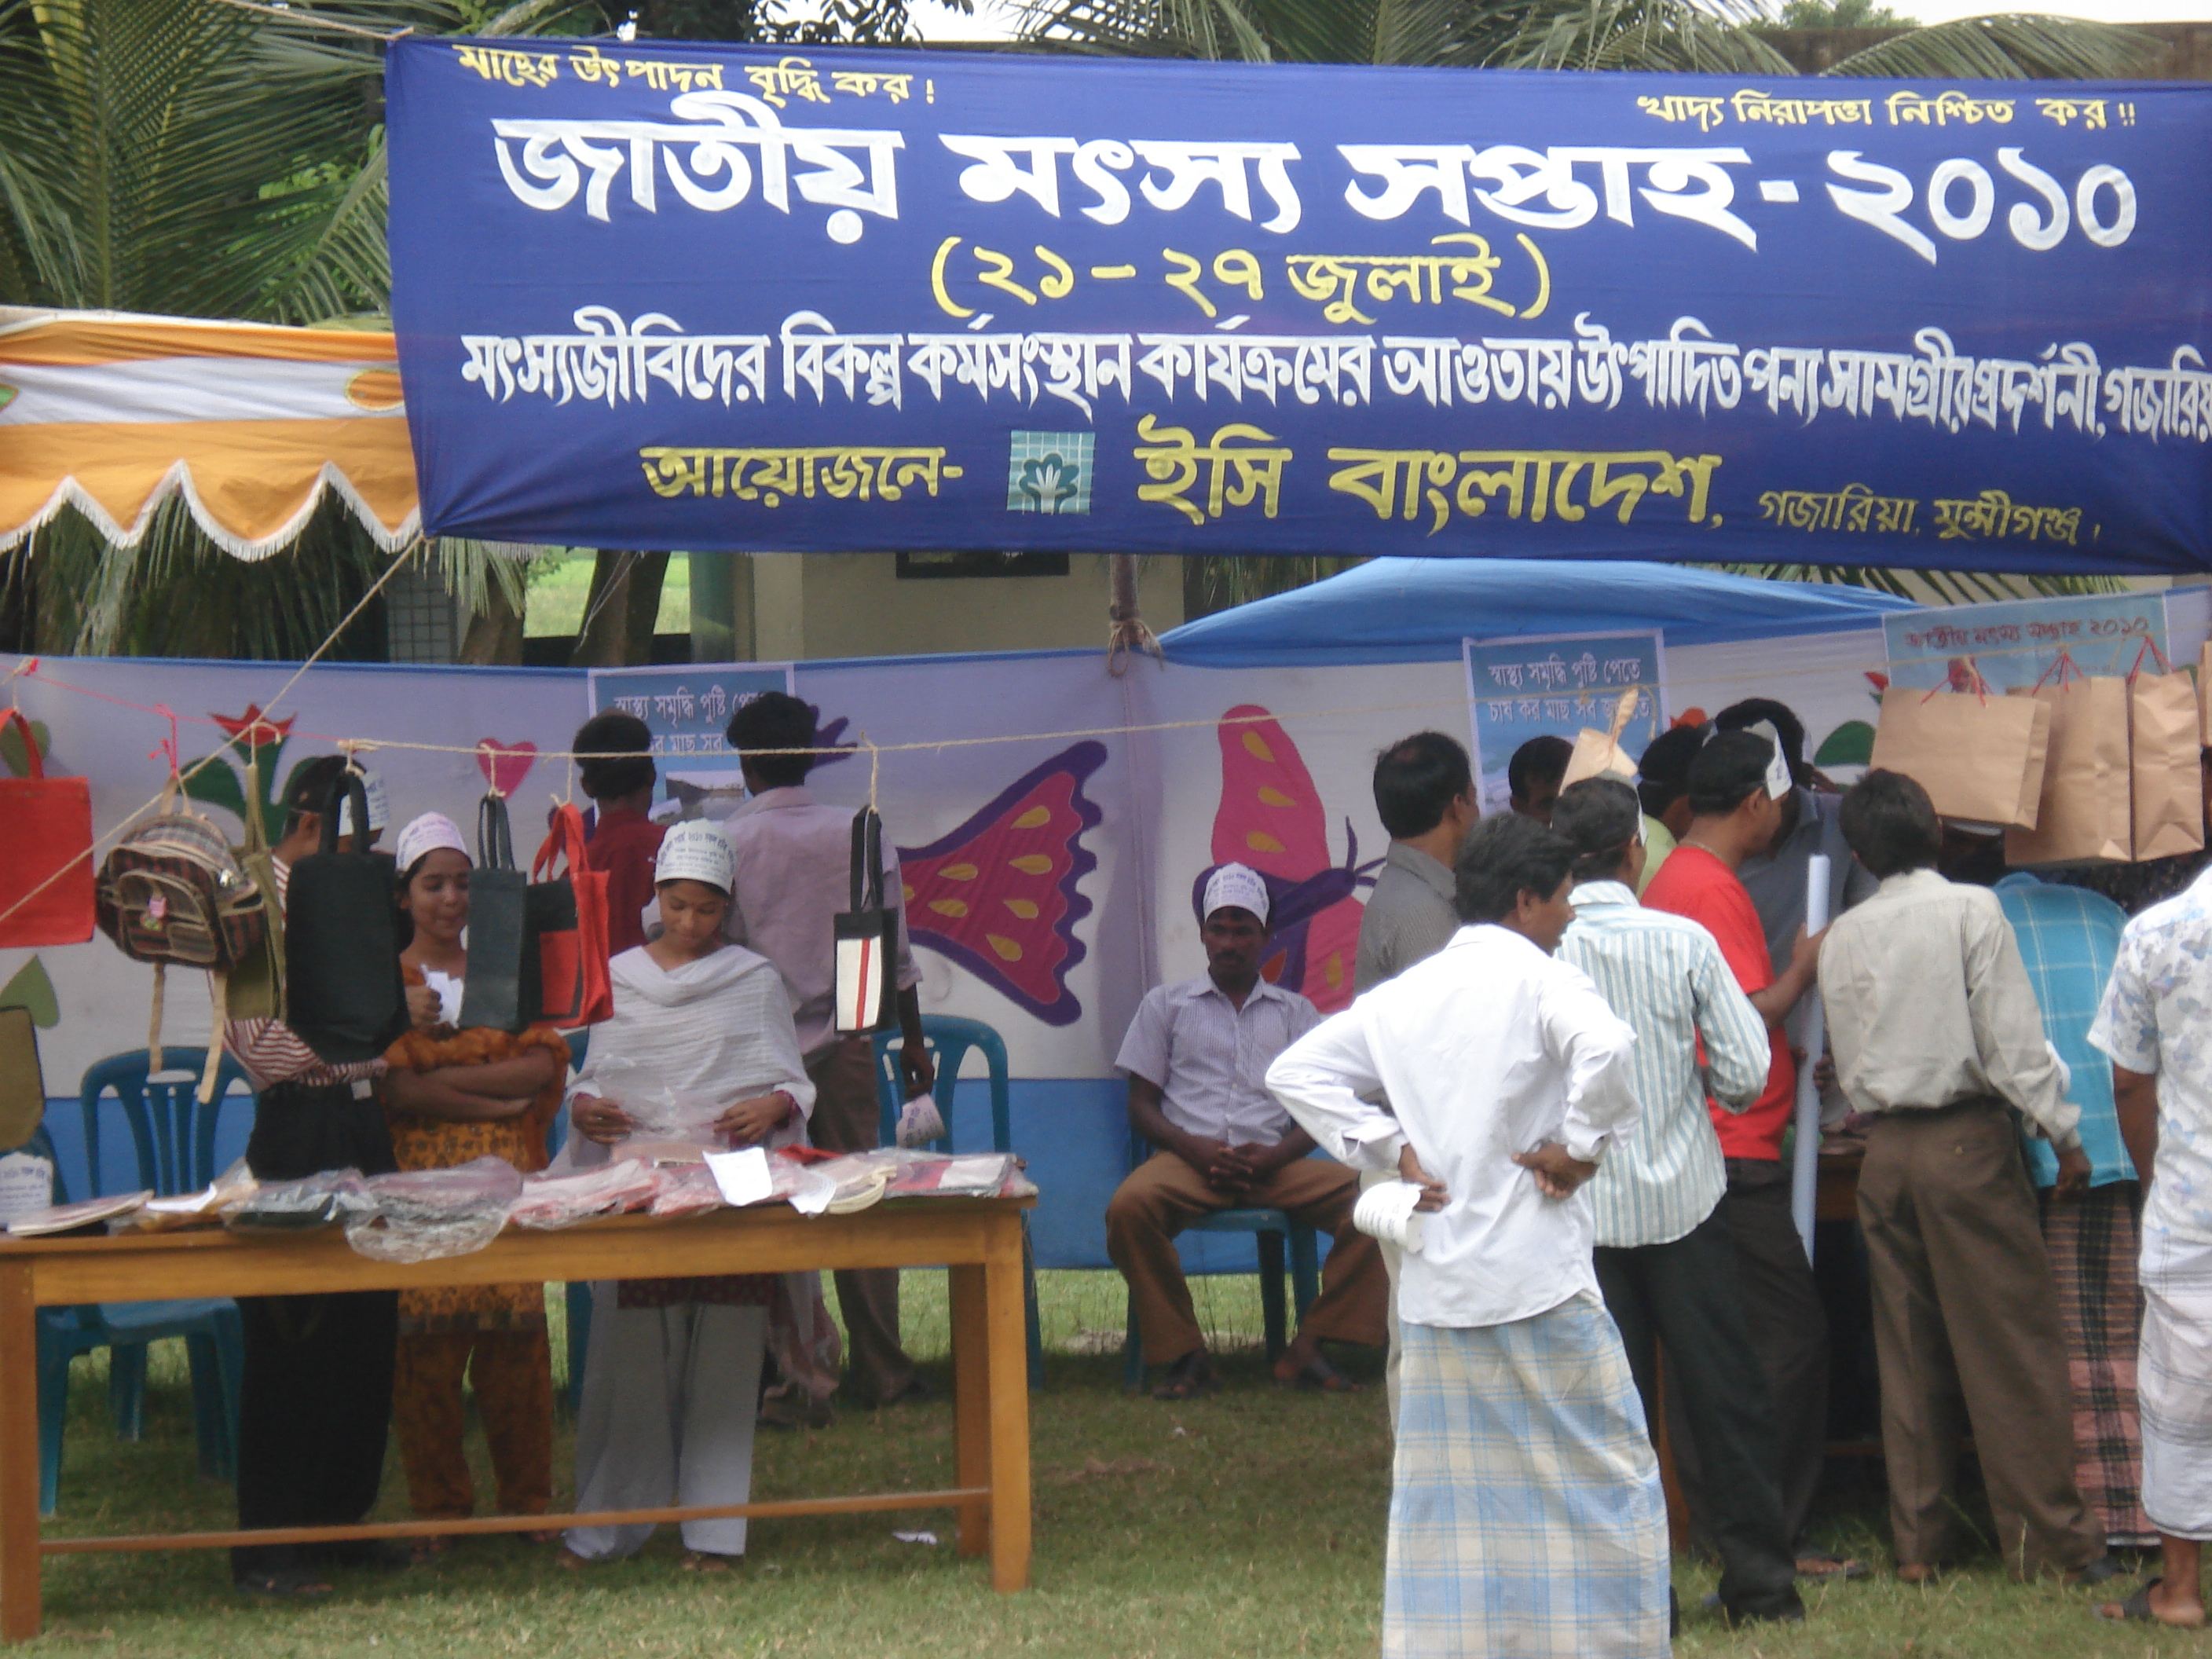
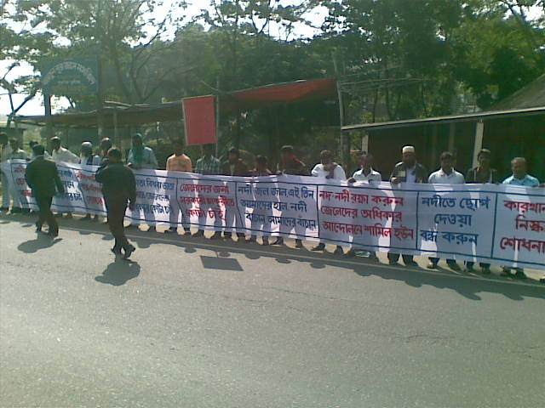 |  |  | 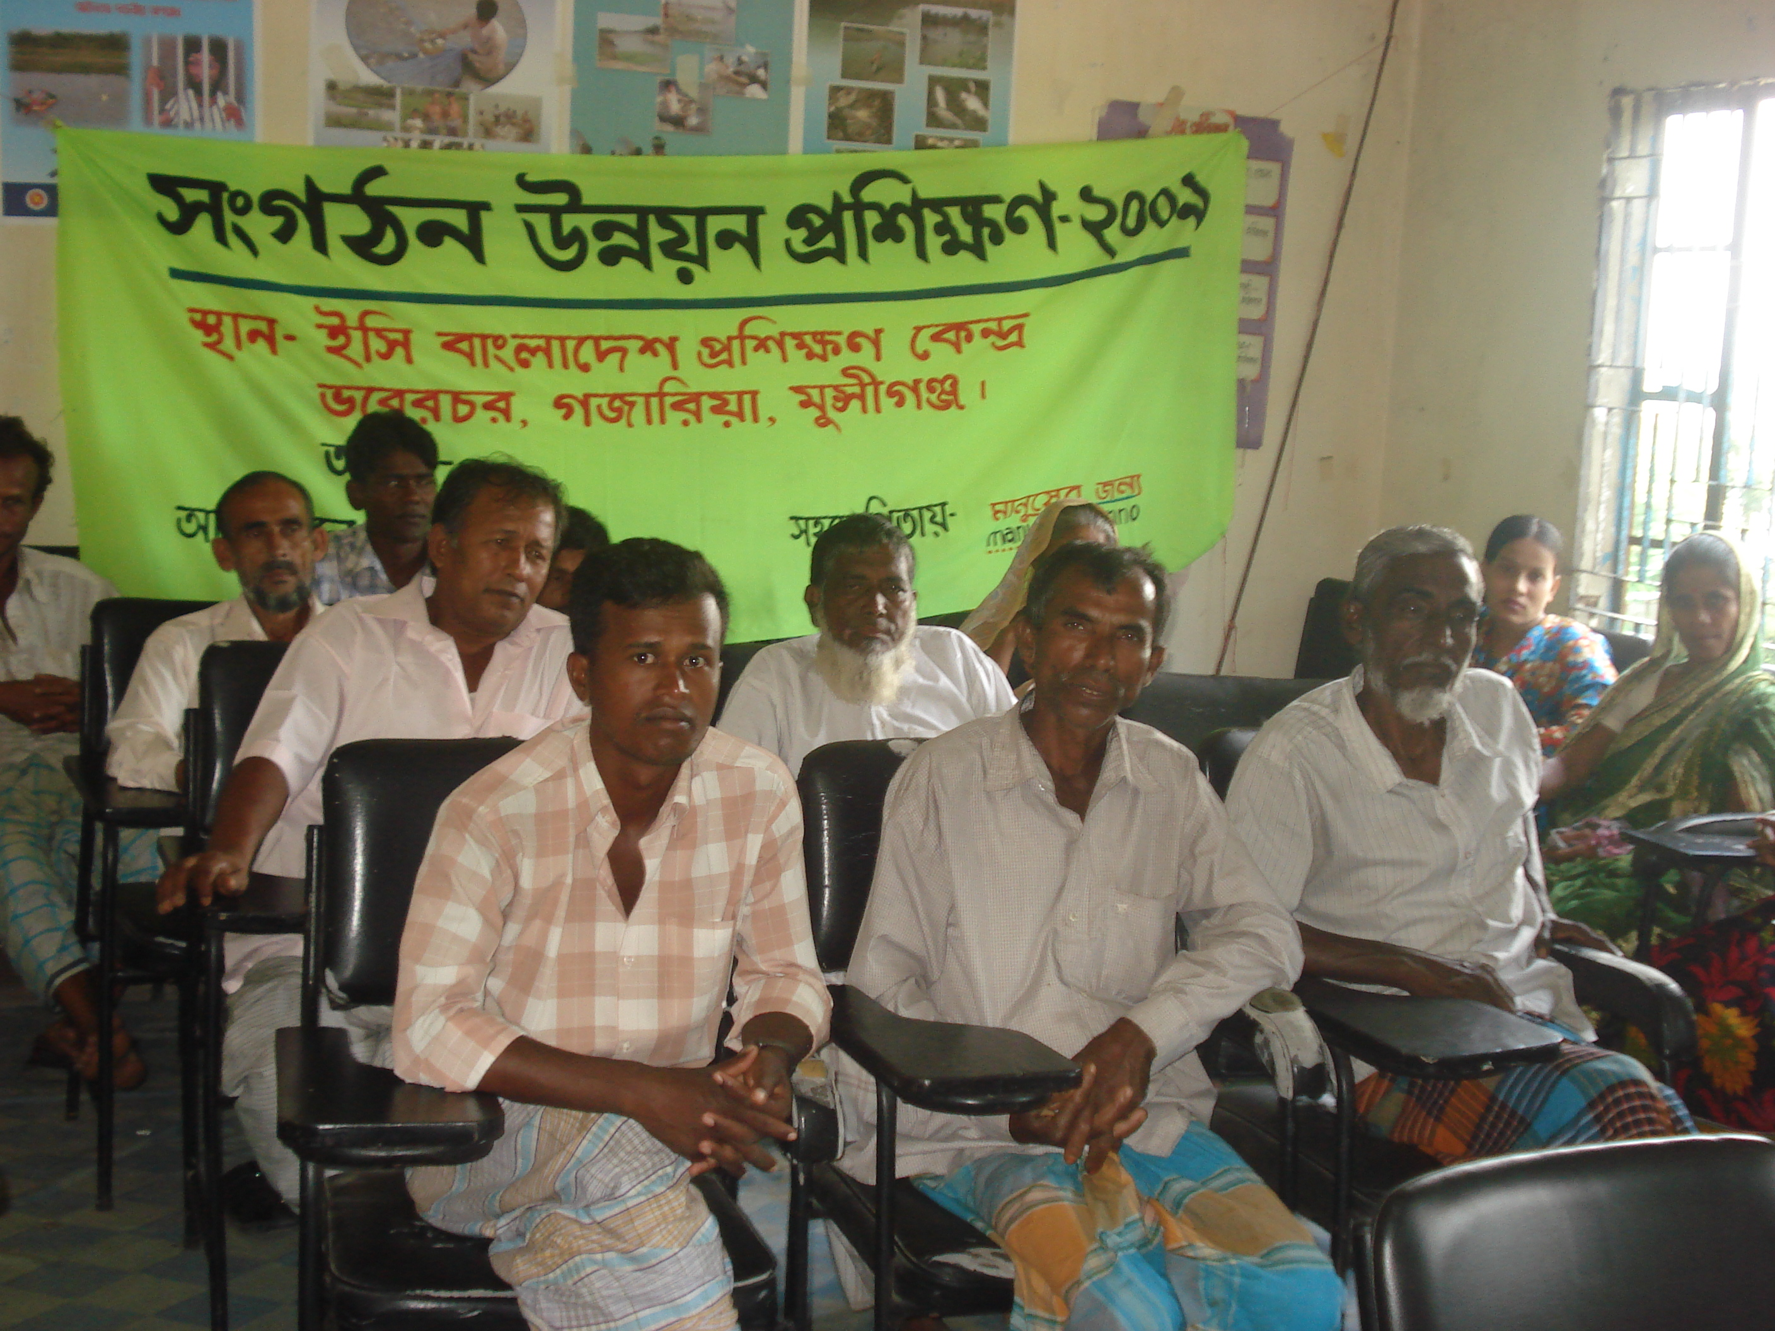
Project Location :  Gazaria upazila of Munshiganj District and Sonargong Upazila of Narayangonj district |  |  | Approx. Value of the Contract :  BDT 22,745,039.00  US$ 284312.98
Name of Donor & Address :  Manusher Jonno Foundation  House # 47, Road # 35/A  Gulshan-2, Dhaka-1212  Bangladesh  Tel: +880-2-9850291-4  IP Phone: +880-9609-444888  FAX: +880-2-9850295 |  |  | Duration of assignment (months): 76  October 2006 to June 2013
Beneficiaries :  Direct: About 9007 Men and Women Fisher  Indirect : More than 45035 people |  |  | Name of venture partner :  N/A
Goal:
The Project Goal is “Improved livelihoods of the marginalized fishers through promoting and protecting rights
Objectives:
- To strengthen the Fishermen federation of Gazaria to bargain for equal access to the open water bodies, natural resources and contribute to resolving conflicts
- To improve access to quality Health services, Education, Water, Sanitation & Other support services related to fishing activities
- To enhance additional income options for fishers households through access to financial and occupational opportunities
Narrative Description of Project:
This project deal with promoting and protecting the rights of marginal fishers of Meghna Basin. This project covers all their traditional and non-traditional fishers and the household members of Gazaria Upazila of Munshiganj District and Sonargaong upazila of Narayangonj distrcit
Description of actual services provided in the assignment:
The major services included are as follows:

Strengthening the Group Activities and the Federation
The project will develop and strengthen a Fishermen Federation and will monitor continuing technical and financial supports so that they can overcome their limitations to resolve conflicts and raise voice for the fishers.

Capacity Building of the Federation Members
The beneficiaries will receive diverse capacity building training, workshop and meetings on different issues such as, Rights, Livelihood, Resource Management, Health, Nutrition, HIV/AIDS, Education, Environment etc.

Campaign, Advocacy and Policy Dialogue
The project will implement various activities to reduce the violation of the fisher’s rights. Campaign, Advocacy and Policy Dialogue will be held to make mass people aware, change any existing rules or laws, to make concerned the duty bearers.

Advocacy/Meetings with Duty Bearers for Improved Services to the Fishers
The duty bearers will be active to protect the rights of the marginal fishers due to the intervention of this project component.

Media Campaign/Advocacy, Round Table Dialogue, Spot Visit and Feature Publication
Media is an important element now to implement any kinds of development project. This project will involve electronic and printed media to disseminate the messages and program news to mass people.

Promote Livelihood Security Opportunities for Fishers Community
Numbers of beneficiaries will receive Information Generation Trainings from the Project and the Project will also make linkage with Financial Institutions so that the trained people will get involved with IGA taking loan from the Financial Institutions with less interest.

Linkage Development with Financial Institutions
The Project will also make linkage with Financial Institutions so that the trained people will get involved with IGA taking loan from the Financial Institutions with less interest.

