Project Description

Title | : | Assessment on the Essential Service Delivery (ESD) Program in NGO Clinic and UPHCP
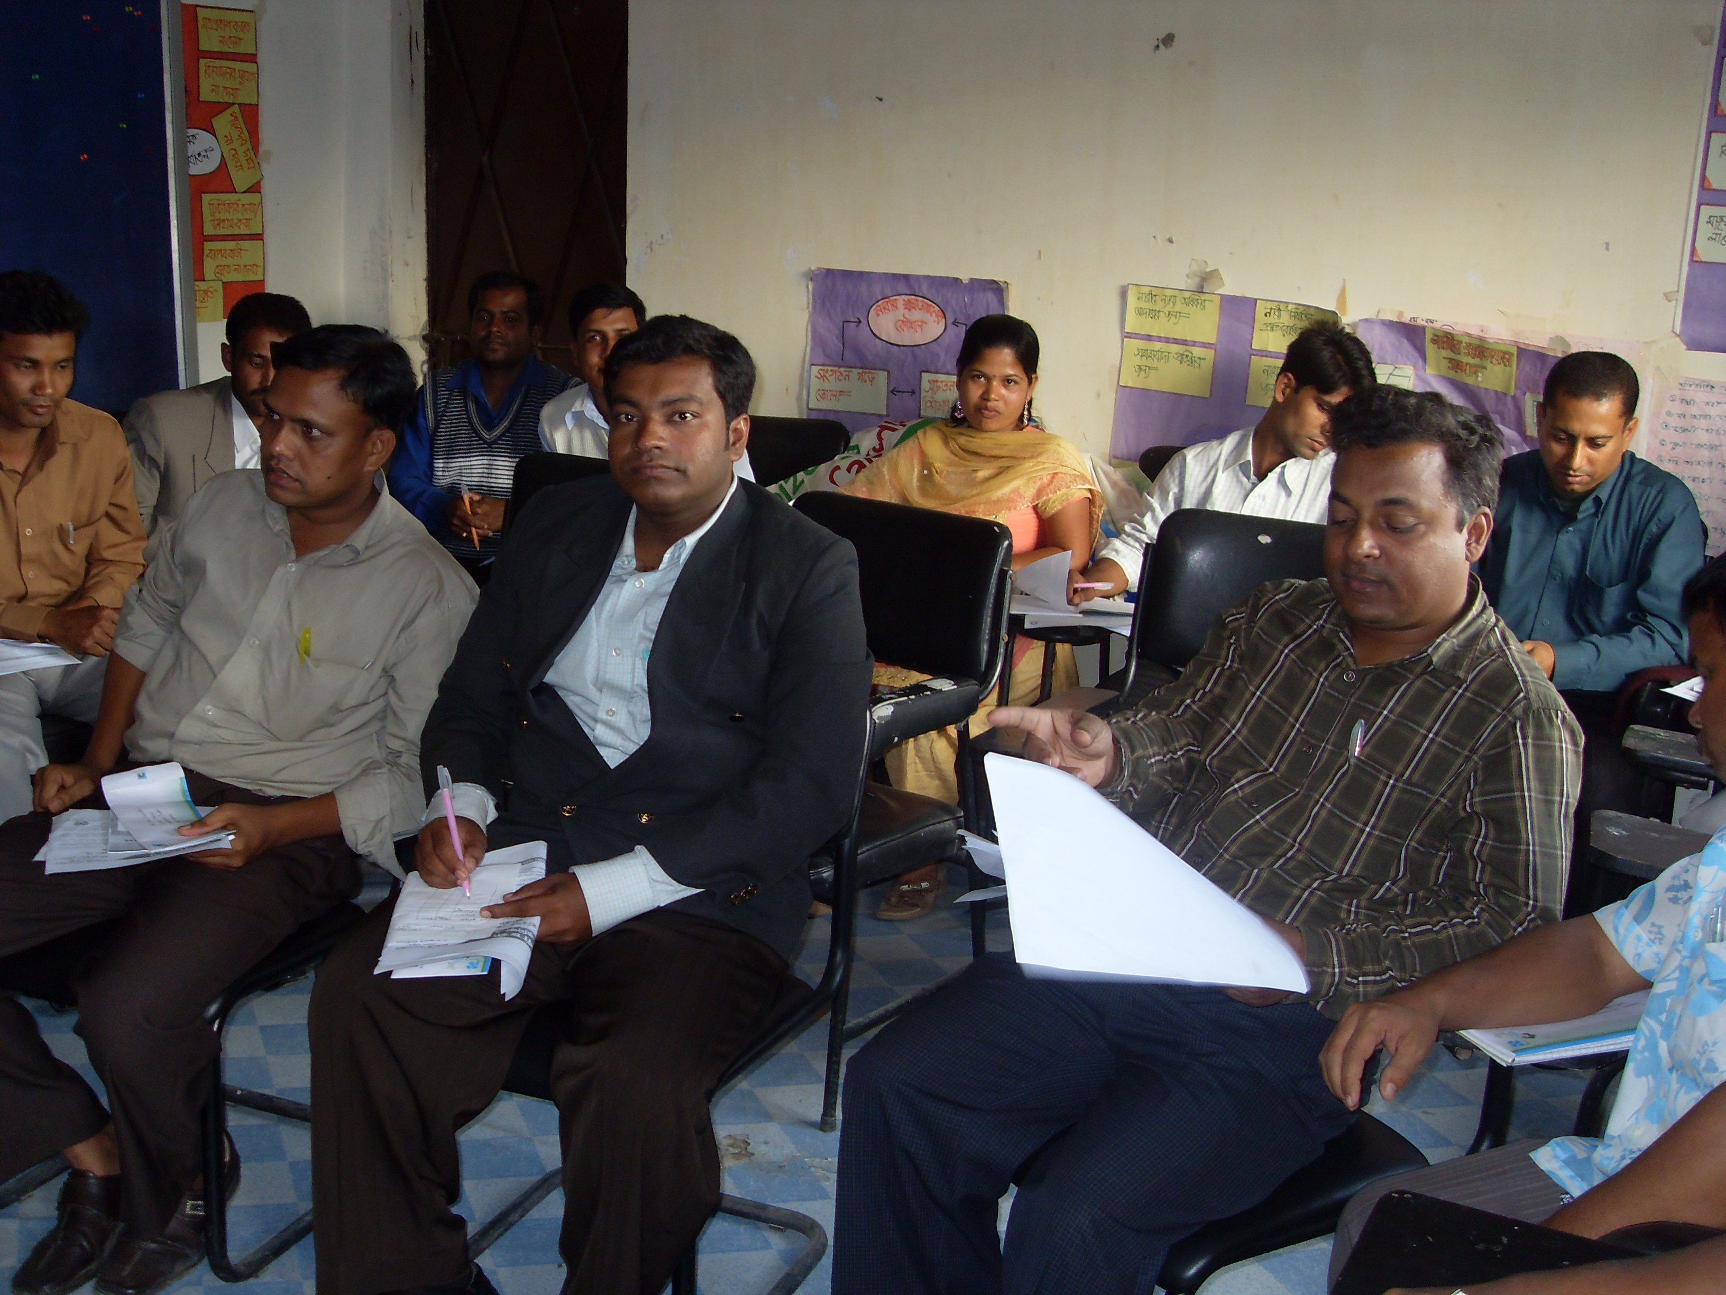 |  |  | 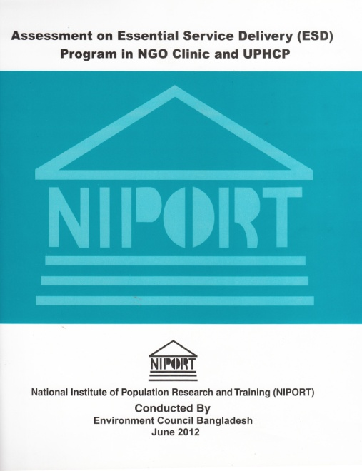
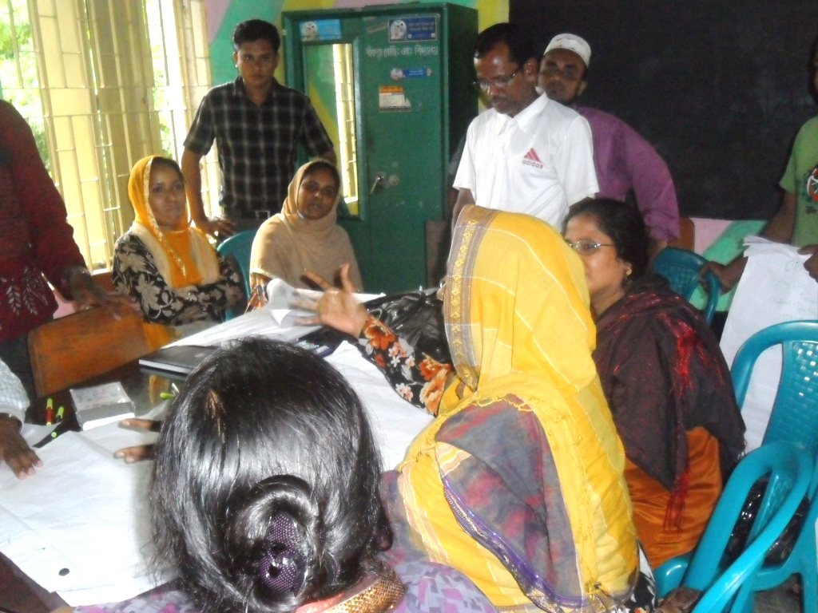 |  |  | 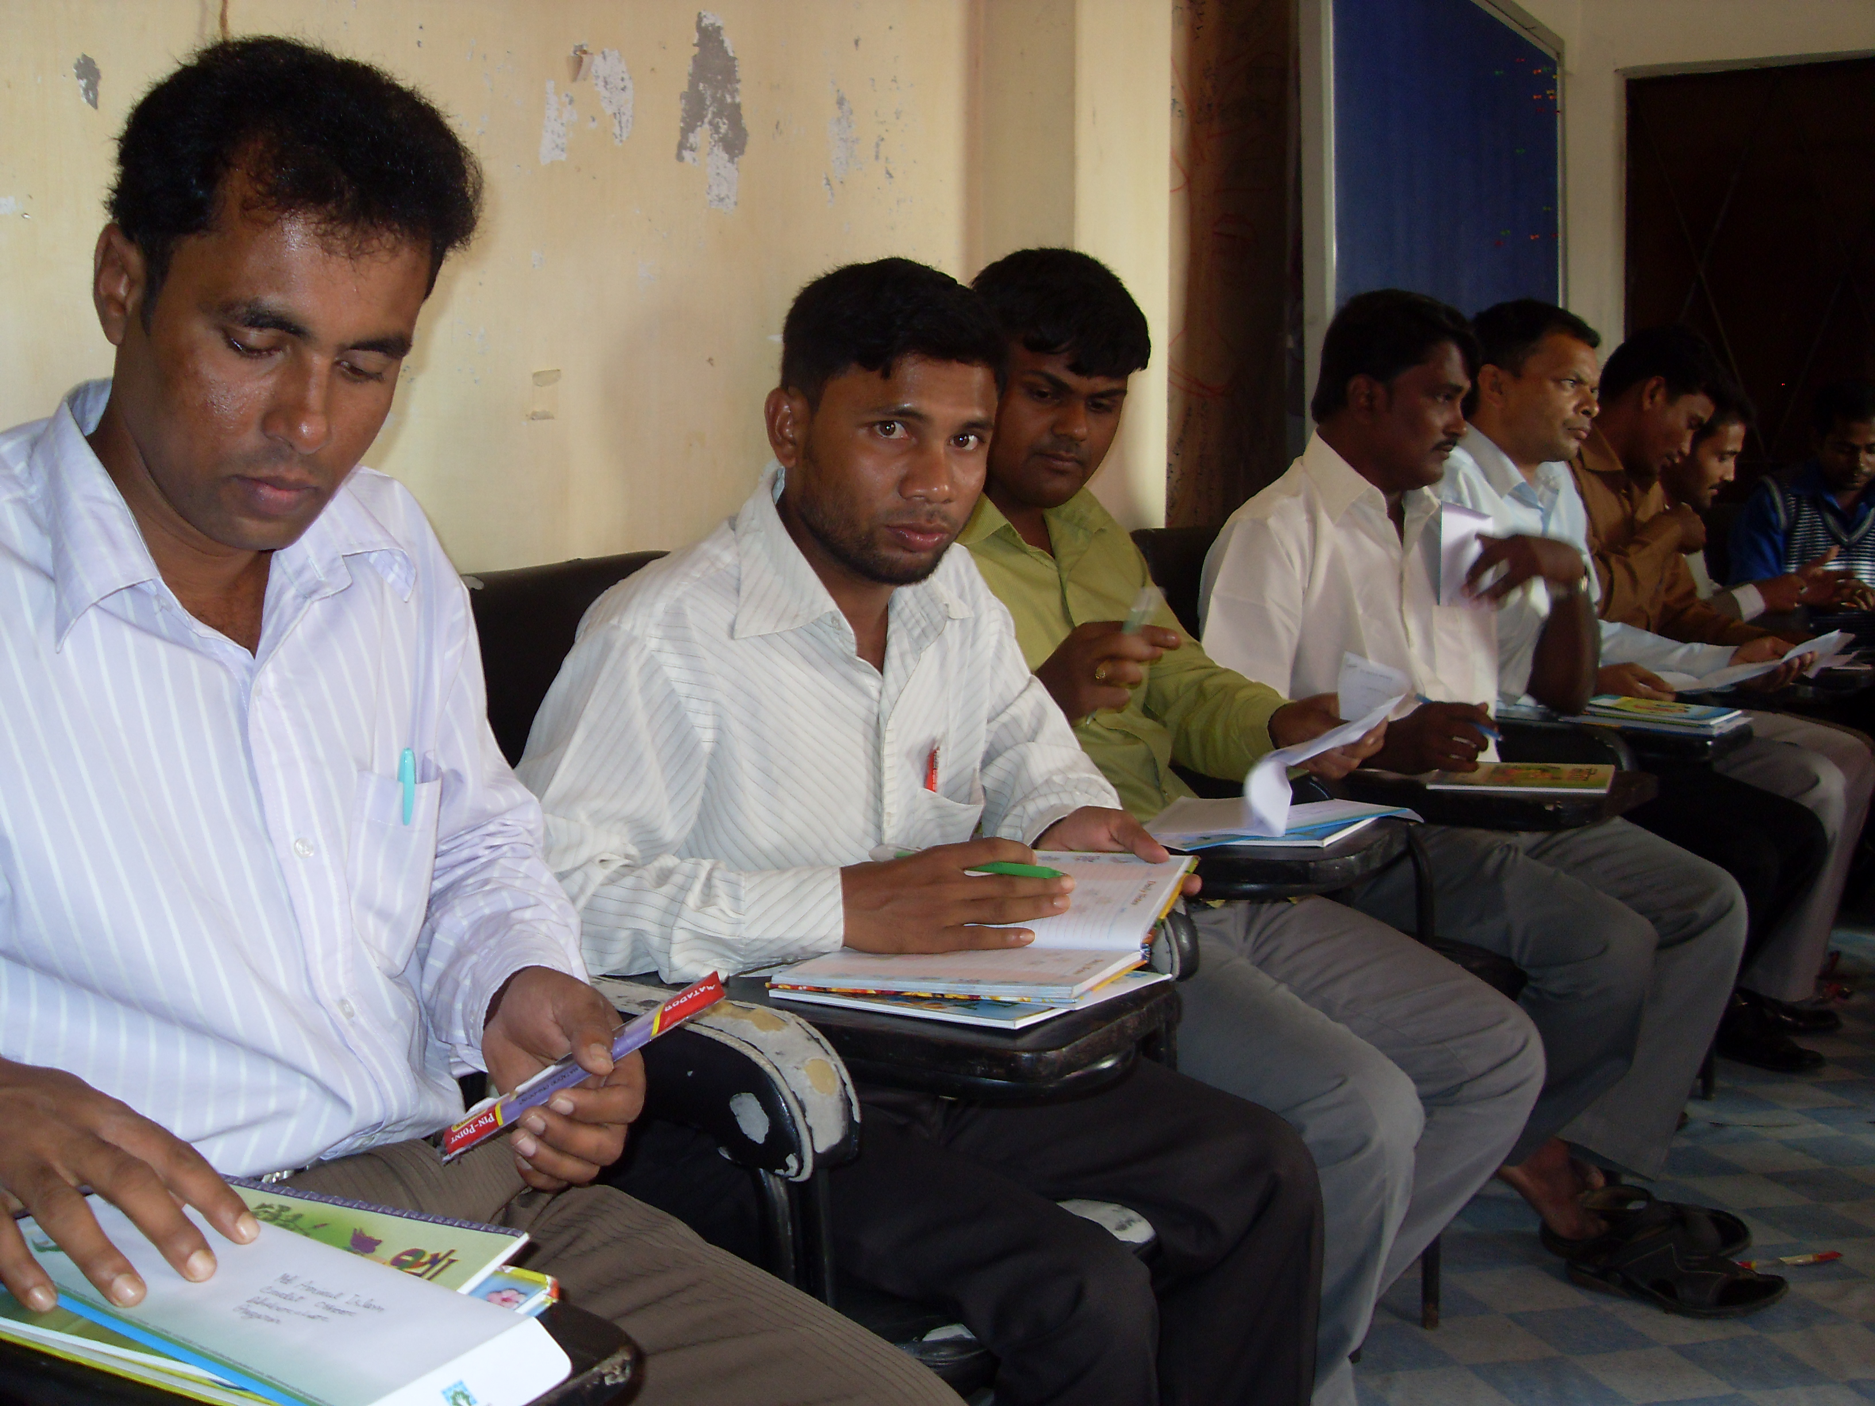
Project Location :  All district of Bangladesh |  |  | Approx. Value of the Contract :  BDT : BDT 1,474,322/-  USD: 18834.76
Name of Donor & Address:  NIRORT, MoH&FW |  |  | Duration of assignment (months): 3  May 2012 to July 2012
Beneficiaries :  Direct: Service receiver and provider of Health providing institutions |  |  | Name of venture partner :  N/A
Goal:
The general objective of the study is to assess the capacity and utilization of the NGO Clinic and UPHCP for implementation of Essential Service Delivery (ESD).

Objectives:
The specific objectives of this research are as follows:
- To investigate type of providers involved in the service of the NGO Clinic and UPHCP
- To investigate their experience and training to provide ESP
- To investigate their capacity to provide services at the NGO Clinic and UPHCP level
- Investigate facilities
- To investigate the exit clients of the NGO Clinic and UPHCP to assess their opinions about their service
- To investigate the opinions of the community level influential’s about the capacity of the service providers
Narrative Description of Project:
The project was aimed to indentify the real situation of the service in the community clinic in Bangladesh. The assignment was contracted with NIPORT/ Ministry of Health and Family Welfare. Study data were collected from Service providers, service receivers, community influential, relevant Government authority through questionnaire, KII, FGD, literacy review etc.
Description of actual services (Major activities under the program) provided in the assignment:

Questionnaire Interview
Research team has prepared 3 three types of questionnaire such as questionnaire for manager level service providers, questionnaire for mid level service providers, questionnaire for service receivers in order to collect data for this study. A total number of 285 persons have been interviewed during this study through following simple sampling method.

Focus Group Discussion (FGD)
A total no of 12 Focus Group Discussions were conducted under 12 NGO Clinic and UPHCP centres areas. Focus Group Discussions were conducted to understand the views and opinions of service providers; community influential’s and service receivers concerning the ESD Program in NGO Clinic and UPHCP operation. The participants for the FGD have been considered (i) clients, (ii) community influential, (iii) two types of service providers both mid and top level staff, and (iv) Thana officials. In each focus group 10 to 12 participants have participated for discussion. Focus Group Discussion (FGD) have created the scope to participate collectively all types of individual who are directly or indirectly involved with this ESD Program in NGO clinic and UPHCP centers.

Observation
The research team will make the plan to observe actual situation of the ESD Program in NGO Clinic and UPHCP centers considering low, medium and high performance. The team will visit about 6 no of NGO Clinic and 6 no of UPHCP centers during their service period. The observer will prepare an in-depth report after completion the observation. This observation method will help to reach the data accumulation.

Interview of Key informant
The study included some interviews of key informant. Through this interview a good number of data and information have been collected. This interview has been conducted with PIU of City Corporation and Civil Surgeon etc. A total 48 no of Key Informant have been Interviewed. This type of interview helped to ensure check and balance of the study.

Data editing coding:
During this study a data has been editing in various ways. After collection of data from, supervisors have edited at field level and when all data has been collected and transferred to head office the research team has again edited those data finally. All of data has been coding during this study.

Data Analysis
After completion of all types of data and information collection, the expert computer programmer completed the data input. He prepared a data base with all types of data collected from the field during this study. The research team analyzed data for making the draft report after collection of all data and designed assessment activities.

Report Writing
A report has been prepared and submitted to the authority of NIPORT within the expected dated mentioned in the TOR. A total 200 copies of printed report have been submitted.

