Project Description

Title | : | Post Literacy and Continuing Education for Human Development (PLCEHD-1)
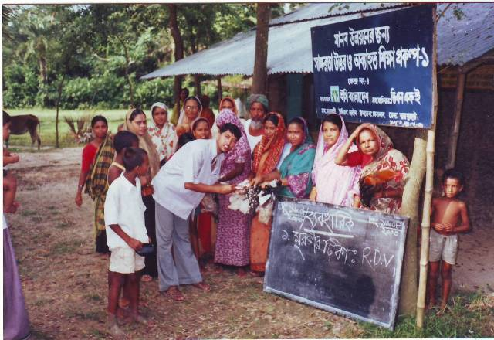 |  |  | 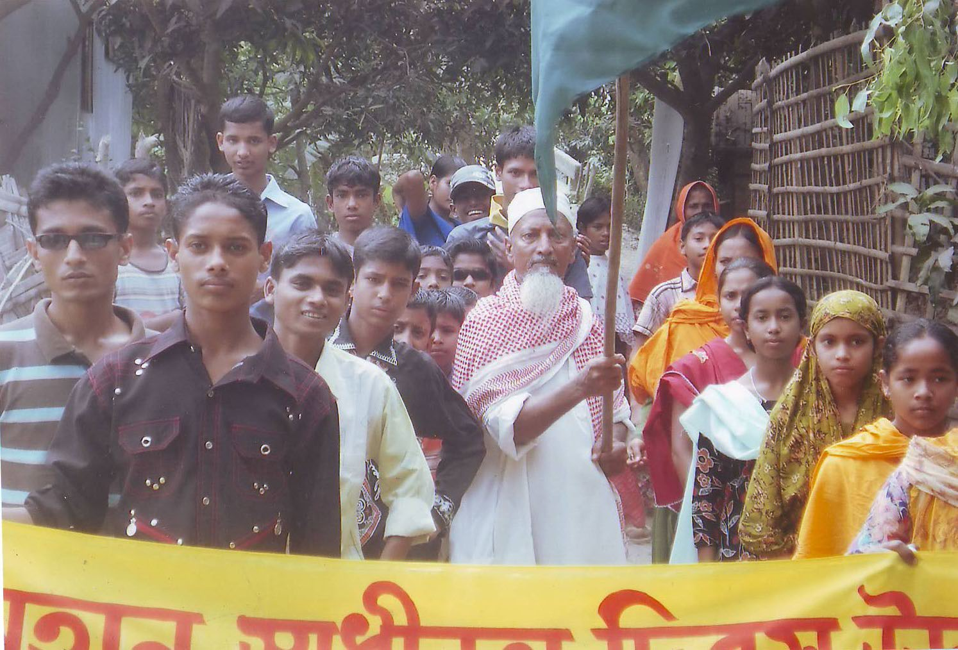
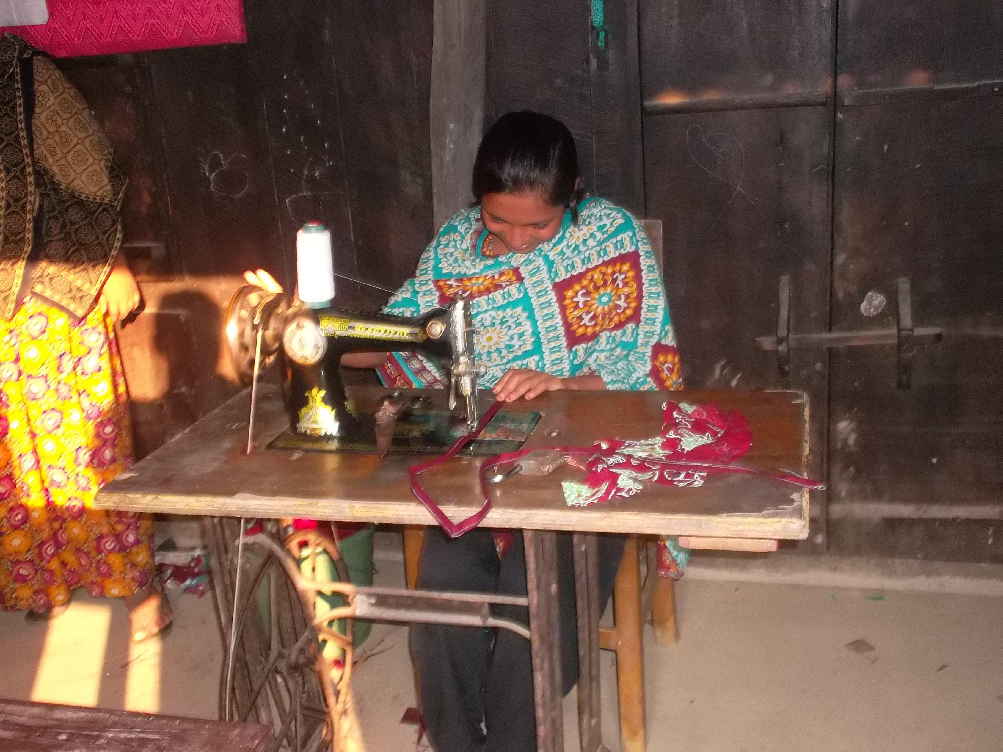 |  |  | 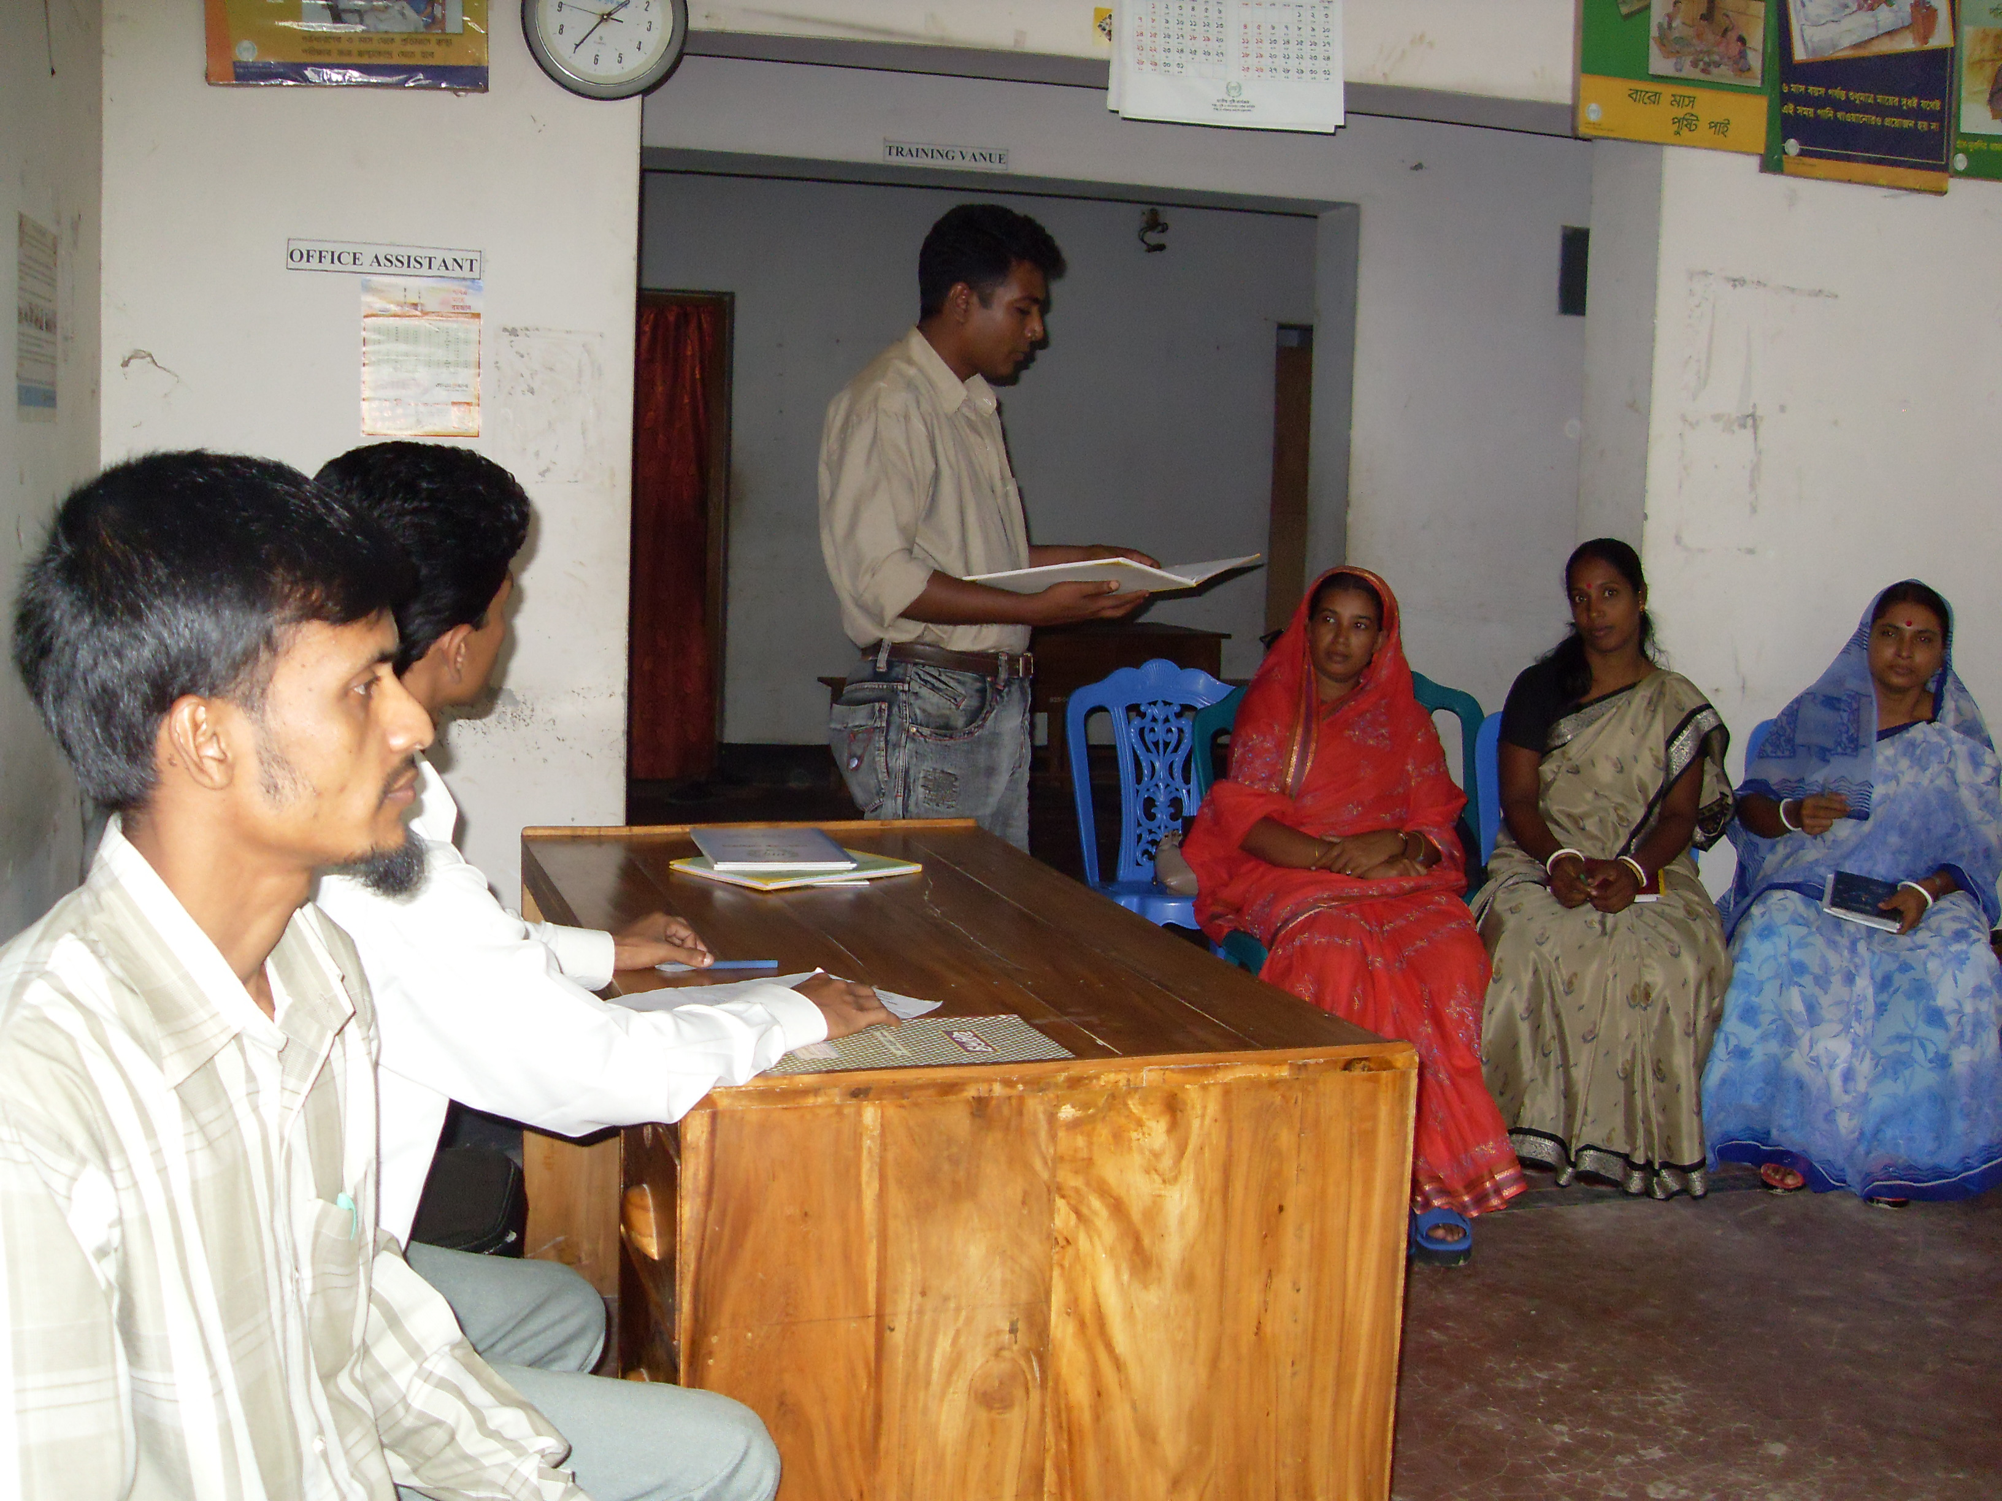
Project Location :  Kethlal upazila of Jaypurhat District, Kahalu upazila of Bogra District & Lohagora upazila of Norail District |  |  | Approx. Value of the Contract :  BDT : 52,00,000.00  USD : 66431.04
Name of Donor & Address :  Ministry of Primary and Mass Education (MOPME), Tejgaon, Dhaka |  |  | Duration of assignment (months): 24  1st November 2009 to 1st February 2012
Beneficiaries :  Direct: About 1965 Adult women, 1642 Adult Men, Indirect: About 2470 Adolescent |  |  | Name of venture partner :  N/A
Goal:
To achieve Education for All (EFA) program of the Government as well as to develop the life pattern of the learners

Objectives:
- To develop human resource by providing with skill development training
- To make people aware of their right to education
- To increase gender knowledge and decrease women violation
- To increase peoples participation with socio-economic development
- To create linkage with supporting agencies for their development

Narrative Description of Project:

The main task of the INGO is to help the learners to improve their acquired basic literacy skills, encourage them to get regularly involved in post literacy activities and become aware of their rights and responsibilities; motivate the learners to apply their skills at individual, family and group levels (in their productive, family and social role); make the learners aware of the availability of government and non-government facilities and to prove them with the information as to how to have access to and derive benefits from these facilities; organize training to develop skills at the local levels considering; learners' demand, demand for goods and services in the local market and available opportunities for skills training in the area; enhance the social standing of the neo literate by helping improve their conditions and livelihood; develop technical skills and capacity of neo literate for getting them involved in continuing education activities and ultimately, help development the neo-Iterate as an enlightened and productive citizen, eliminate gender disparity and establish social equitability expediting women empowerment.

Description of actual services (Major activities under the program) provided in the assignment:

Formation of CEC management committee
The project has formed a Center Management Committee (CMC) in each education center and mobilizes them to establish and operate the CMC effectively. Thus 50 CMC has been formed under this project. The committee was consisting of 7 members such as: 1 chairperson, 1 secretary general and 5 member.

Provide training to the staff:
In collaboration with Assistant Director of BNFE at District level office, EC Bangladesh has organized different types of training to master trainers, supervisors, Facilitators and CEC management committee members to develop their skill.

Arrange supply of learning materials, furniture and equipment
In order to conduct education and learning activities different types of learning material furniture and equipment has been provided to the center within these cycles. Following table shows that how many materials for the learning center has been provided by the project during the project cycles.

Meeting of DNFEC, UNFEC and CMC:
EC Bangladesh has conducted the meeting with District Non-Formal Education Committee (DNFEC), Upazila Non-Formal Education Committee (UNFEC) as well as Centre Management Committee (CMC) in all upazila and the meeting regulations have been preserved properly for the documentation.

Centre opening and provide Literacy course
EC Bangladesh has operated a total number of 50 centers in Kethlal upazila of Jaypurhat District, Kahalu upazila of Bogra District & Lohagora upazila of Norail District. Each centre have opened and started post literacy and continuing education course at the same time. The Upazila Chairpersons and Upazila Nirbahi Officers, another government officials and local respective and influential as well as EC Bangladesh representative have been invited to the opening ceremony.

Linkage program
Linkage program is one of main activity of the project. A check list of various services providing Government and Non Government organization have been prepared and hanged to the centre notice board so that they learners can choice to gain employment and other opportunities. EC Bangladesh staff communicated and regular met with those organizations in order to create scope for linkage the learners. EC Bangladesh participated to Fare organized by BNFE where learners shown and presented their knowledge and skill as well as displayed their production in the stall. Following table shows that how many graduate learners got linkage with different institutions within two cycles.

National Mourning Day Observance
Within this project period, different national mourning days such as World Literacy Day, Independence Day, 15 August etc has been observed by EC Bangladesh. On the occasion of day observation rally, meeting etc has been organized. In the day observation project staffs, facilitators, trainers, learners, local people, Center Management Committee members, teachers as well as others staff of EC Bangladesh has been participated.

