Project Description

Title | : | Vulnerable Group Development for Ultra-Poor (VGDUP) Project
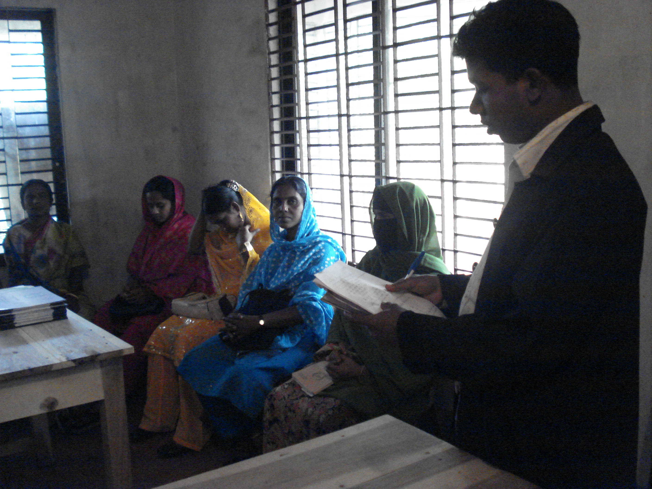 |  |  | 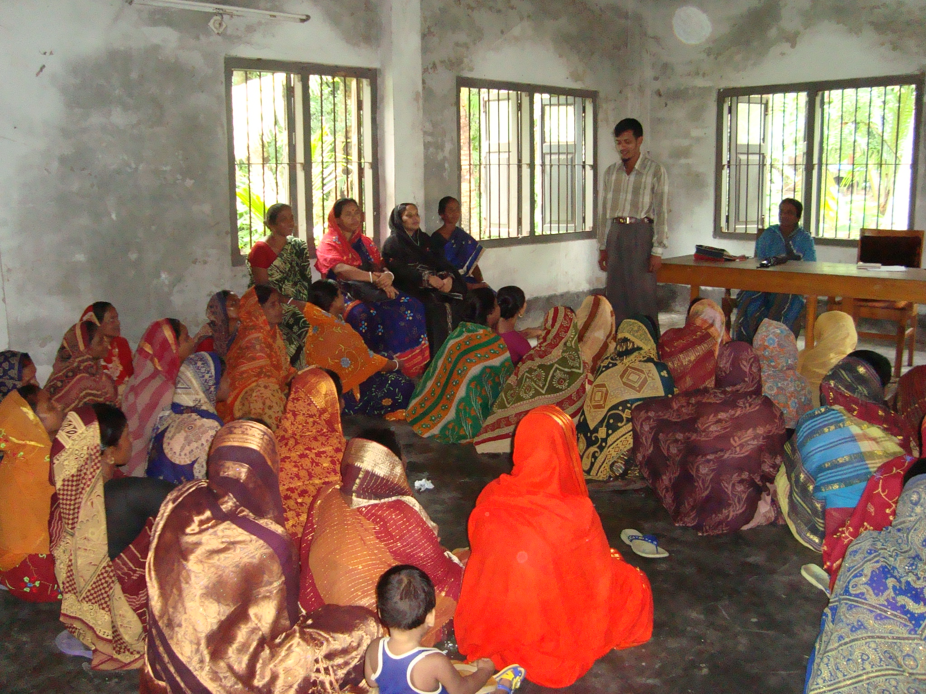
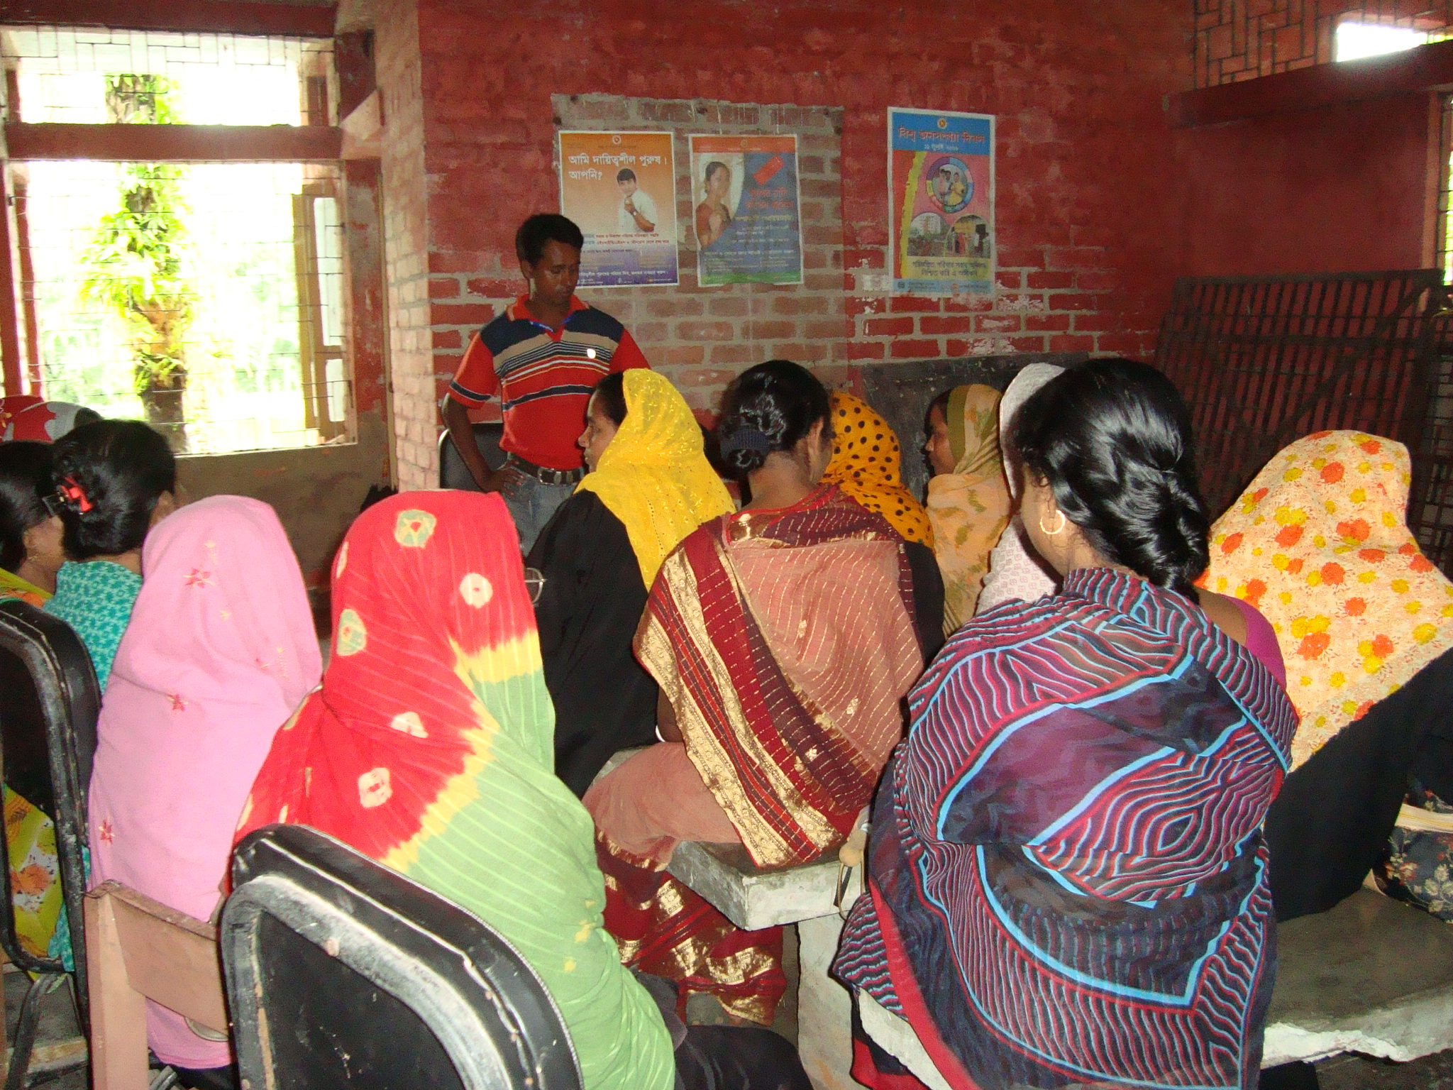 |  |  | 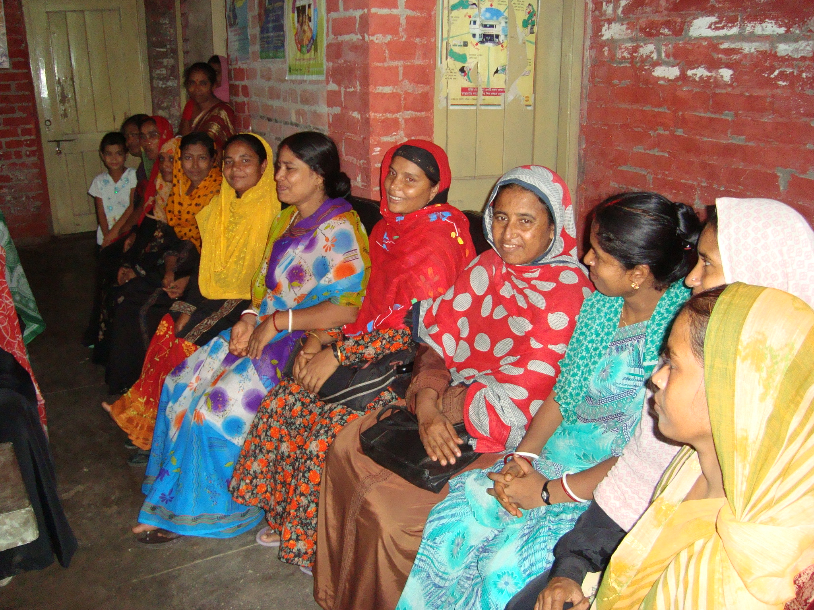
Project Location :  Manikganj Sadar and Doulotpur Upazila of Manikganj District |  |  | Approx. Value of the Contract :  BDT : 1339600  USD : 17236.22
Name of Donor & Address:  Ministry of Women’s and Children Affairs/ Department of Women Affairs, 37/3 Eskaton Garden Road, Dhaka |  |  | Duration of assignment (months): 22  March 1, 2015 to December 31, 2016
Beneficiaries :  Direct: 3152 Ultra poor Women of Women Headed Families |  |  | Name of venture partner :  N/A
Goal:
To improve the quality of life and enhance the productive income generating opportunities of Vulnerable Group development (VGD card holder) of women

Objectives:
- To provide life skill training on Income Generating Activities as well as on Nutrition, Primary Health, Human Rights, AIDs, Reproductive Health, Gender, and Environment issues.

- To provide with the training to support VGD women through subsistence allowance asset transfer and savings creation so that they can engage in self employed income generating activities.
Narrative Description of Project:
This project has been implementing with the support of Ministry of Women’s and Children Affairs to improve the livelihood of vulnerable women in Manikganj Sadar and Doulotpur Upaziila under Manikgaj district. The project has covered 3152 vulnerable women. The activities incorporate training, material and technical support.
Description of actual services provided in the assignment:

Group Formation:
For the implementation of training program, EC Bangladesh has formed 126 no of groups under Manikganj Sadar and Doulotpur Upazila of Manikganj District. Each group contains 20 - 25 VGD card holder women.
Savings collection:
It is mandatory to collect savings from the VGD women @ 10 per week. Savings are being collected from VGD women on weekly basis in the group meeting by the field staff of EC Bangladesh.
Savings deposition system:
EC Bangladesh has opened a separate Bank Account for each Upazila in the name of "VGD Savings Account." Bank Account has been jointly operating by the concern Upazila Women Affairs Officers and District Coordinator of EC.
Training Program:
EC Bangladesh is implementing the training program with the participation of VGD women in respective upazila. The basic part of the training is building awareness on different functional issues, contribute to change attitudes and generate commitment to bring changes in the behaviors and practices in the functional life. On the other hand, they are being received IGA skills development training to enhance the livelihoods and self-reliance through increasing income.

